Cottage or Shepherd’s Pie for Two

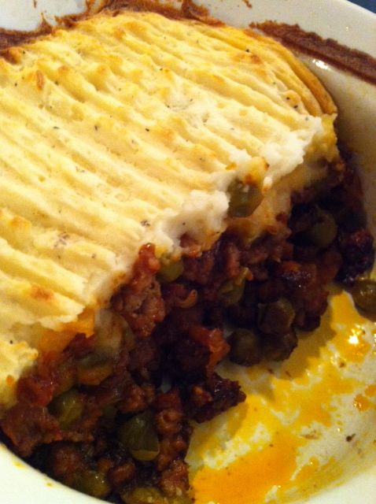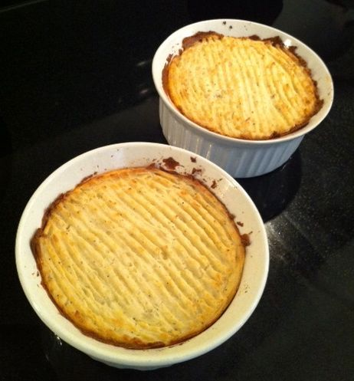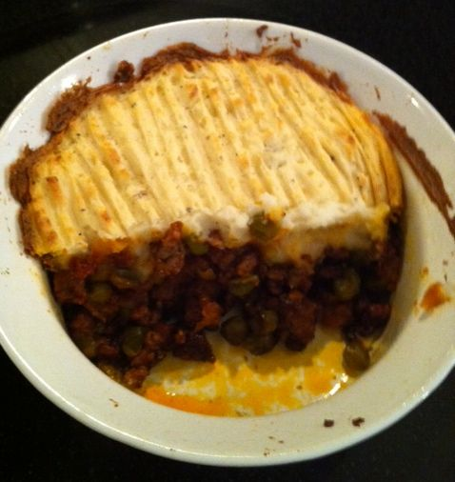

Ingredients:
8 ounces ground meat (beef for cottage pie, use ground sirloin or ground round; for shepherd's pie, use the same quantity of ground lamb)
1 very small onion or shallot – about ⅛ of a cup (3 tablespoons’ worth), diced
1½ teaspoons "beef tea" or any type of beef browning sauce, like "B-V Broth and Sauce concentrate," or your favorite steak sauce – I like English HP sauce!
1, 8.5-ounce can peas & diced carrots (drained)
¾ teaspoon tomato catsup/ketchup ("sauce," as the Brits say – I make my own)
3 tablespoons tomato paste
1½ teaspoons Worcestershire sauce
1½ teaspoons flour
¾ teaspoon cornstarch (or "cornflower," as the Brits say)
1½ cups (12 ounces) mashed potatoes – Bob Evans brand sells a 12-ounce pack of two single-serving cups that is perfect for this recipe if you can’t make your own
Special equipment: Two 16-ounce (round) ramekins, between 2 - 2½ inches tall, and 4½ - 5½ inches in diameter.

Preparation:
Grease the ramekins and preheat the oven to 375° F.

Crumble the meat thoroughly in a medium-sized skillet, season with salt and ground, black pepper; brown with the onions (drain as much of the fat out as you can while browning).

Mix all the wet ingredients, except the tomato paste and vegetables, with the cornstarch and flour (before they are heated in the pan) into a saucy paste, then stir it thoroughly into the meat. Add the tomato paste and the peas & carrots, mix well and heat thoroughly; divide the warmed mixture equally and transfer half to each of the ramekins.

Warm up the mashed potatoes. Pack the meat mixture into the ramekins, making sure it's smooth and level, then cover the tops of each evenly with as much mashed potatoes as will fit on top without spilling over the sides of the dish. Use a fork to make homey little criss-crosses in the potato topping!

Bake 30 to 45 minutes, until the potato-topping is golden brown. Let cool for about five minutes before serving (serve in the ramekins).

