Homemade Corned Beef & Cabbage with Vegetables (serves 8)

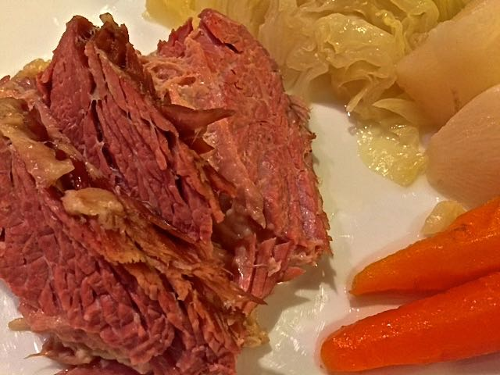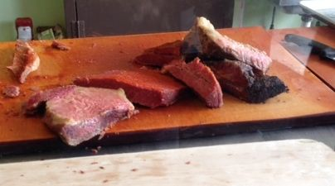

Here, the traditional Irish meal of corned beef and cabbage is supplemented with turnips, carrots, and boiled potatoes. Serve it with a loaf of Irish soda bread (see my recipe for it at the following link: http://www.seabrite.com/Recipes/British%20&%20Irish/Irish%20Soda%20Bread.doc ).

Note that the brisket needs to brine for two weeks, so plan ahead.

Ingredients:
2 quarts water
½ cup table salt
1 tablespoon pink curing salt (see notes)
½ cup sugar
1 teaspoon coriander seeds, crushed in a spice grinder
1 teaspoon yellow mustard seeds, crushed in a spice grinder
1 teaspoon black peppercorns, crushed in a spice grinder
1 cinnamon stick, crushed (I put it under a cutting board and whack it good)
4 dried bay leaves, whole
8 whole cloves
6 – 8 pound flat-cut beef brisket
1 medium onion, unpeeled, but halved
1 large rib celery, washed and halved
1 large carrot, unpeeled, but washed and halved
2 pounds small turnips, peeled, trimmed and quartered
2 pounds small carrots, peeled, trimmed
1 large head cabbage, cut into 8 wedges
2 pounds small red potatoes, unpeeled and whole
Mustard sauce, for serving (see notes for recipe)

Preparation:
Bring the 2 quarts water to a boil in a large pot to start the brine. While the water comes to a boil, give the coriander seeds, mustard seeds and peppercorns a good whirl in a spice grinder or small food processor. Once the water is boiling, add the salts, sugar, ground spices, bay leaves, cinnamon and cloves; close the fire/remove from heat and stir until salts and sugar dissolve. Let cool.

Place the brisket in one of those enormous turkey-basting plastic Ziploc bags. In the alternative, place it in a nonreactive container just large enough to hold it. Pour the cooled brine over meat. Place 2 small plates on top to keep meat submerged; cover (or, with the enormous Ziploc, squeeze out all the air so the liquid completely surrounds the beef), and refrigerate for 14 days. (Yep, two weeks!)

After two weeks of brining, rinse the brisket and discard the brine. Place the brisket in a large stockpot (you may have to cut it in half and stack one half on the other in the pot if it’s really big). Add enough water to cover by 2 inches. Add the halved onion, celery, and large carrot; bring to a boil. Reduce heat, cover, and simmer until very tender, 3½ hours. Note that the brisket will reduce in size. Remove the brisket to a cutting board (I put it on a parchment-lined baking sheet) and tent with aluminum foil. Discard the onion, carrot and celery.

Bring the broth in the pot to a boil. Add the potatoes, turnips and small carrots; lower heat to a low boil and let simmer 15 minutes. Add in the cabbage wedges and simmer an additional 10 minutes. Transfer vegetables to a platter. If the turnips and carrots don’t seem tender enough for you, zap them a minute in the microwave.

Trim excess fat from beef. Slice thinly against grain, and transfer to platter. Serve with mustard sauce (see notes below for the recipe).

Notes:
Also known as “sel rose” and “curing salt,” pink curing salt develops flavor (it’s dyed pink so butchers can tell the difference between it and regular salt). It contains a very small percentage (about 6%) of sodium nitrate, which prevents bacterial growth. It also helps keep the meat a nice color. The brisket can be made without it, but the result of course won’t be as intense.

Here’s the recipe for traditional, Irish mustard sauce (made with ingredients we can find in grocery stores around here):

Mix together well the following in order to make enough for 8 servings of this corned beef & cabbage -

¼ cup Guldan’s or other brand spicy, brown mustard
¼ cup Grey Poupon or other brand Dijon mustard
¼ cup butter, softened to room temperature
¼ cup mayonnaise

