Chicken Pot Pies for Two
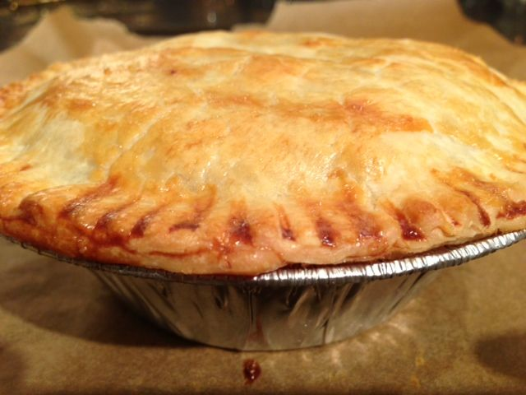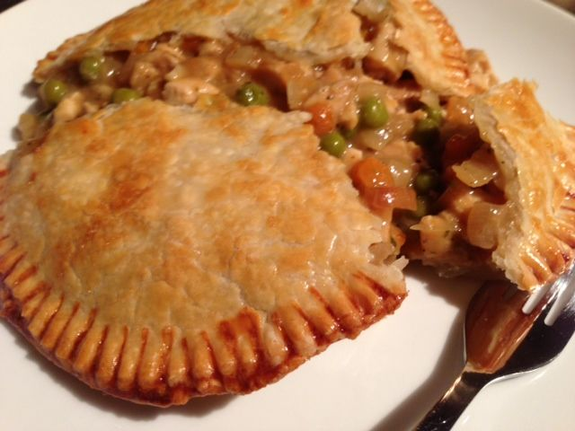

Ingredients:
8 oz. skinless, boneless chicken breast or ready-grilled chicken strips, diced
1, 8.5-oz. can peas and diced carrots
1, 10¾ -oz. can condensed cream of chicken soup
1 medium onion and 1 clove garlic, minced
1 tablespoon Worcestershire sauce
¼ teaspoon each of salt, garlic powder, ground, black pepper and celery salt
2, 9-inch diameter sheets frozen, ready-rolled pie pastry, thawed
olive oil and/or butter for frying, 1 egg beaten with 1 teaspoon water for glazing pastry

Preparation: Preheat oven to 425º F.
If using fresh chicken, cover the bottom of a medium-sized skillet with oil and bring it to medium-high heat. Season the chicken breasts well with the salt, garlic powder and black pepper, then brown them a few minutes on both sides in the pan in oil or butter. Remove chicken from the skillet after it's nicely browned and allow it to cool off a bit.

Next, mince the onion and garlic, season with a little salt & pepper and sauté in the browned chicken drippings (or a little oil/butter) until caramelized on medium-low heat.

While the onion browns, dice the cooled chicken meat into tiny cubes. After the chicken is cubed and the onion and garlic is nicely caramelized, place all remaining ingredients (except of course for the pie-crust dough) in the skillet and simmer the mixture gently for about six to ten minutes over low heat, just to warm it through really well and to mingle all the flavors together.

Tip a pie tin over on the first pastry sheet and cut a circle around it. Repeat process to make another circle (these are the pie lids). Place pie tin on second sheet to cut a circle that's slightly larger than the tin (about ½” larger for the pie base). Repeat process to make another. Depending on what brand is used, you may either have to roll the second pastry sheet out with a rolling pin slightly larger than sold, or utilize the scraps from the first sheet and roll them all together to make a large sheet that will allow you to make the larger circles.

Press base pastry into pie tins and press up the sides. Fill each with half of the chicken mixture. Brush rims with egg mixture. Place pie tops over filling. Use a fork to press edges to seal. Trim edges if necessary. Brush tops with more egg mixture and cut a steam-vent hole in the top of each pie, as there will be quite a lot of filling.

Place pies on a foil- or parchment-lined baking sheet and bake for 20 minutes, or until golden. Serve with French-fried potatoes (“chips”)!

