Chicken Pie (“Chickens go in, pies come out!”) – recipe serves 6 – 8

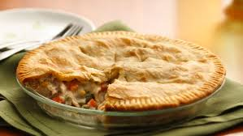

Ingredients:
16 ounces (more or less) skinless, boneless chicken breasts, diced
14 ounces (more or less) peas and diced carrots
1 10½-ounce can condensed cream of chicken soup
1 medium onion, finely chopped
2 tablespoons Worcestershire sauce
¼ teaspoon each of salt, garlic powder, ground, black pepper and celery salt
2 nine-inch pie crusts, top and bottom (see notes below)
Vegetable oil, to sauté the chicken and onion

Preparation:
Preheat oven to 400º F. Sauté the chicken in oil with the onion until browned and caramelized over medium-low heat.

Place all remaining ingredients (except of course for the pie-crust dough) in the pan with the chicken and onion; thoroughly combine and simmer the mixture on low heat gently for about six to ten minutes, just to warm it through really well and to mingle all the flavors together.

Place your first pie shell in a compatibly sized pie tin or glass pie baking dish, and transfer the warmed mixture into it. Cover with a second pie layer of shell, trim edges neatly of excess dough with a knife and pinch edges together to seal in the meat filling. Brush the top of the pie shell with a little olive oil (or egg wash) and cut four or five decorative slits in the top so the pie is able to vent while baking.

Bake for approximately 30 minutes, or until the crust is golden.

Notes:
Traditionally, the Brits make these more often with a single puff-pastry top crust. But I love these with the more usual and ordinary type of piecrust!

