Bubble & Squeak

Here's a good recipe for our vegetarian friends to make. The Brits are famous for naming common dishes after the sounds they make while cooking - "Bubble & Squeak" is a classic example of that (I've never been able to get it to "squeak" while cooking, though). I've always heard of this dish being made primarily from cabbage and potatoes, but some out there insist that it's traditionally made from Brussels sprouts and potatoes. I love both cabbage and Brussels sprouts, so I make it with both.

Ingredients:
1 pound whipped/mashed ("smashed") potatoes
8 ounces cabbage and/or Brussels sprouts, cooked and finely chopped
1 tablespoon or so of vegetable oil
1 onion, finely chopped

Preparation:
Heat enough oil in a large skillet to cover the bottom. Add the onion and simmer until soft. Add in the potatoes and cabbage/Brussels sprouts. Mix everything together well, then fry over medium heat for about 15 minutes (turning once in a while). You should end up with square whipped-potato patties, about 4" x 4", fried as crispy as you can get them on the outside with tasty little green and golden-brown bits on the inside.

Serve by itself as a main course or as a side dish (a "bit of bubble" is traditionally served as one of many components of the famous "full English breakfast"). I also like to add in about a cup of fried bacon bits. Enough of this will fill you right up!

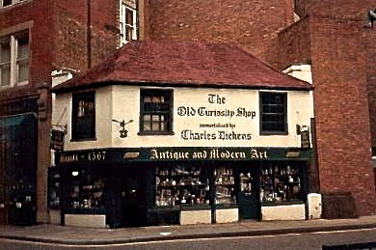

The Old Curiosity Shop in London made famous by Charles Dickens (photo circa 1987).

