British Chicken in a Pot – recipe serves 2

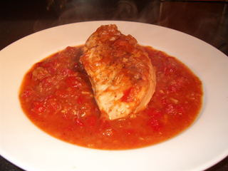

A long-standing, supper-time favorite in Great Britain, there are many different takes on the recipe for this savory dish. Here is a very simple, but hearty and delicious (not to mention time-tested), basic version of it featuring a classic sauce of slow-simmered onions, tomatoes and wine that one must taste in order to believe just how incredibly good it is!

Ingredients:
½ pound chicken, any parts you like (I use 2 boneless, skinless chicken breast halves (“supremes”)
1 medium-sized, white onion, finely diced or minced
1 - 2 cloves fresh garlic, crushed or minced
½ teaspoon salt
¼ teaspoon ground, black pepper
1 small tomato, finely chopped (½ cup drained, canned diced tomatoes may be used instead of the fresh tomato)
¼ cup dry, quality white wine (I like using a good sauvignon blanc)
~ oil for browning the meat ~

Preparation:
Season chicken with a little salt and pepper. Then, in about a one-quart pot , brown the chicken in oil until golden brown. Add the onion, garlic, the salt and pepper. Give it all a good, but gentle stir, cover the pot, turn the heat down low and simmer for a good 30 minutes (stirring occasionally).

Next, add the tomato and wine; continue to gently simmer on medium heat, uncovered, for at least another 30 minutes longer (keep stirring once in a while) so that the chicken gets nice and tender, and absorbs the flavors of the sauce mixture.

Be sure to plate a good amount of the succulent tomato-onion wine sauce from the pot on/around the chicken! Any green vegetable and boiled new potatoes go great with this, as well as some hearty, dark bread or Yorkshire pudding to soak up the lovely sauce juices.

