Beef Wellingtons for Two

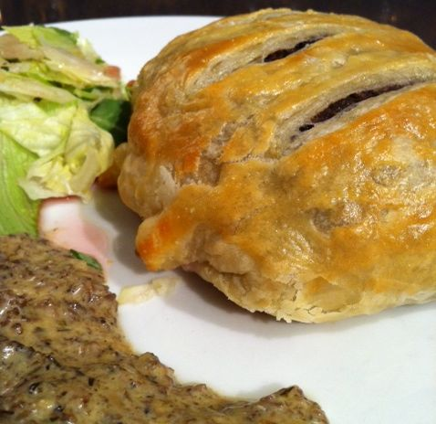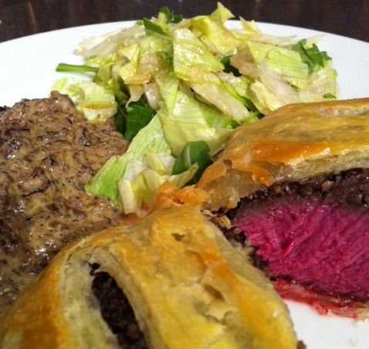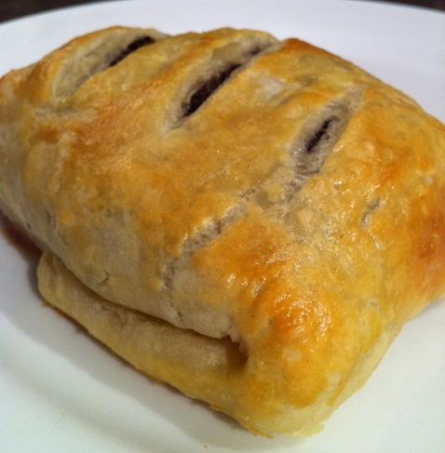

Ingredients:

2, 6-oz beef fillet-steaks 1” thick (top sirloin works great)
1 sheet from a 17.3-oz./1.1 lb packet ready-made puff pastry, thawed
¾ oz. dried porcini or large morel mushrooms
2 small shallots, peeled and minced
8 oz. baby portabella/crimini mushrooms, finely chopped
¼ cup good sherry (the kind you would actually drink)
2 teaspoons dried thyme leaves
1 egg, beaten with one teaspoon water
3 - 4 tablespoons butter
8 oz. heavy [whipping] cream
2 tablespoons olive oil
salt and freshly-ground black pepper
garlic powder
all-purpose flour (to dust work surface)

Preparation:

Preheat the oven to 400° F.

Rinse the dried mushrooms in cold water, then put them into a bowl of hot water – make sure they’re covered with hot water. Soak for at least 20 minutes.

While the porcini soak, heat the oil in a large frying pan until smoking hot. Season the steaks well on both sides with salt, pepper and garlic powder. Seer the steaks for one minute on each side, then remove from the pan and set aside to rest.

Place the shallots into the pan and fry until softened. Add in the butter and crimini mushrooms and cook on medium heat until thoroughly softened and reduced.

Drain the dried mushrooms and finely chop them, then add them with the sherry to the pan. Increase the heat and cook until most of the sherry has evaporated.

Add in the thyme, cook for one minute, then remove the pan from the heat and set aside. Season, to taste with salt and pepper.

Remove the pastry from the refrigerator to a work surface dusted well with flour. Roll the pastry out quickly so as to be able to cut it into two, equal rectangles with which you will be able to wrap up the steaks. Spread enough of the mushroom mixture onto the centers of each pastry-sheet half – enough to equal the size of each steak.

Place a steak on each bed of mushroom mixture, then brush the edges with the beaten egg glaze. Fold up the edges of the pastry so they meet and overlap slightly in the center of the top of each steak - trim off any excess pastry. Turn each over so that they rest seem-side down on a foil- or parchment-lined baking sheet. Cut three, diagonal slits on the tops of each Wellington and brush them all over with some of the remaining egg-water glaze.

Bake for 13 – 14 minutes for medium-rare.

About 10 minutes before the Wellingtons are done, reheat the remaining mushroom mixture. When it is hot, add the cream and simmer on medium-high heat until it is reduced and thickened. Remove the pan from the heat, season with salt and pepper.

Plate each Wellington with an equal portion of the sauce along the side of each (not on top of the pastry!). Serve with buttered peas and a green salad.

