Ballindalloch Chicken – recipe serves 2

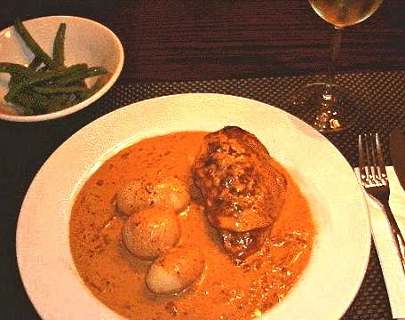

From the Spey Valley in the Scottish Highlands comes this very tasty chicken-and-ham dish. Try it with steamed new potatoes (be sure to cover them well with the wonderful sauce)!

Ingredients:
2 chicken breasts (I use boneless, skinless)
1 small onion, finely chopped
5 fluid ounces cream
¼ cup tomato puree (see note)
2 small/thin slices of ham (Oscar Mayer makes one or two suitable types of deli slices)
4 - 6 tablespoons cheese, grated - a nice English cheddar works great!
1 teaspoon each salt, pepper & poultry seasoning
2 - 4 tablespoons butter (for frying the chicken)
⅛ teaspoon granulated garlic powder (my personal touch)

Preparation:
Preheat oven to 350º F.

Rinse and pat dry chicken breasts, sprinkle with a little salt, pepper and garlic
powder, then fry in butter on both sides until nicely browned.

Place them in a flat dish and cover with a slice of ham.

Fry onion in the remaining butter solids and place on top of chicken and ham. Then sprinkle thickly with grated cheese. Pour tomato purée into the pan, fold in the cream and add the seasoning. Heat the mixture until bubbly and pour over the chicken. Place in the pre-heated oven for 30 minutes.

Serve with brown rice, steamed vegetables, mushies or steamed new potatoes.

Note: ¼ cup tomato puree = ½ Tablespoon tomato paste plus water to make ¼ cup.

