Basic Australian BBQ (“Barbie”) for Two

Australia’s climate is highly conducive to grilling outdoors, and I understand that this recipe has been an Aussie, outdoor standard basically forever! Australians prefer to grill well-marinated meat, and any kind of meat will do, not just beef.

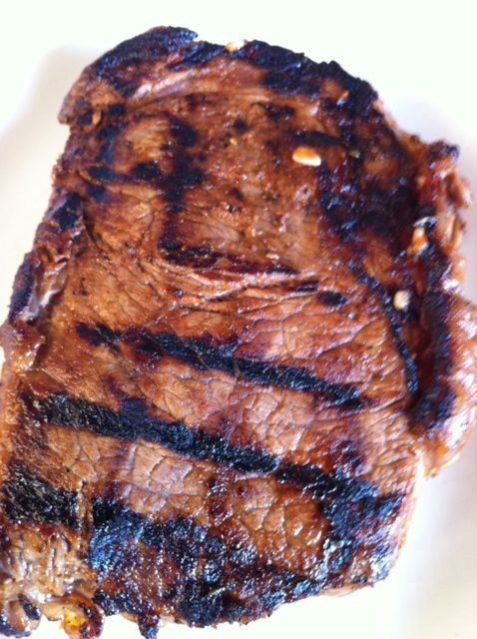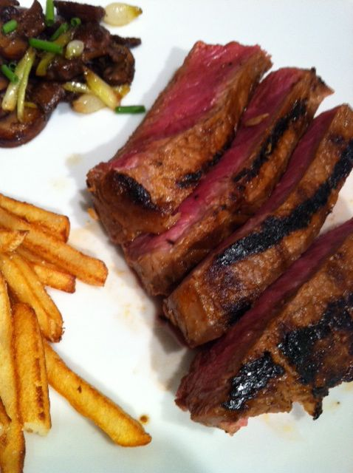

Ingredients:
2 steaks of choice 4 – 6 oz. each, or one large steak of 8 – 12 oz. (divide after grilling)
1 tablespoon olive or other vegetable oil
2 tablespoons red-wine vinegar
2 tablespoons dry, red wine (use what you drink, not that “cooking” wine stuff!)
2 tablespoons of ketchup (more spicy and thicker than Aussie “tomato sauce”)
3 cloves garlic, minced
1 teaspoon mixed, dried herbs of your choosing
¼ teaspoon each salt & ground, black pepper

Preparation:
Place your steaks in a large dish with a lid, or you can use a quart-sized Ziploc bag.

Mix all the rest of the ingredients together well in a bowl, then pour over the steaks (turn steaks to ensure that the marinade coats all sides of the steaks). Refrigerate, covered, for at least two hours, or overnight. While marinating, turn steaks occasionally so the marinade soaks in thoroughly.

Allow the meat to warm up to room temperature before cooking. You can brush the leftover marinade on the meat as it grills, but it would not be a healthy thing to set it out afterwards to serve with the steaks after steeping the raw meat in it for so long!

GRILLING: These times are total cooking times. Divide in half for each side (then divide in quarters, turning the steaks 90º and cooking in that position each quarter interval in order to achieve nice criss-cross char marks). Times are approximate and will vary depending on the type of grill, fuel, weather conditions, etc. DO NOT CLOSE THE GRILL LID – GRILL THE STEAKS “AL FRESCO!”

Thickness Rare Medium Well Heat

1" 8-10 12-14 16-20 High
1½” 10-14 16-20 22-26 High
2” 12-16 18-22 24-28 Medium

