Australian Shrimp on the Barbie

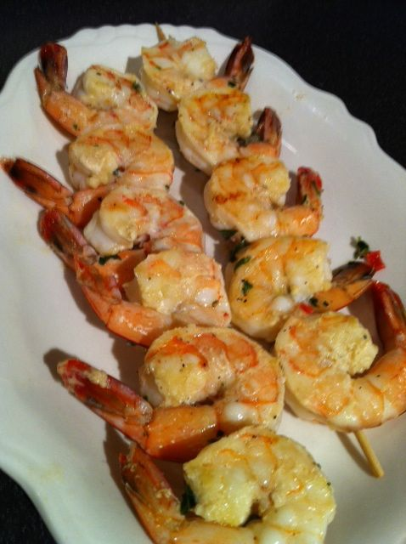 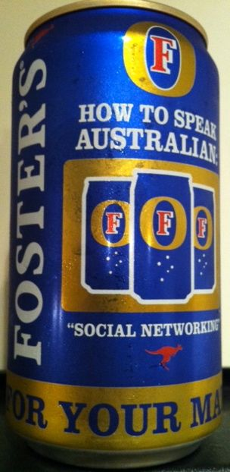 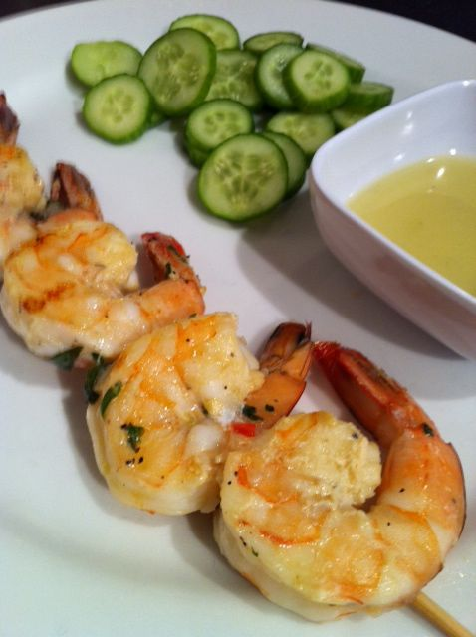 Recipe serves 2.
Actually, Australians say “prawns on the barbie.”

Ingredients:
¼ cup (½ stick) butter, melted
3 tablespoons olive oil
½ cup minced fresh herbs - whatever you have on hand (see notes)
4½ teaspoons fresh lemon juice
2 – 4 garlic cloves, crushed/minced
1 small shallot, minced
¾ teaspoon each salt and ground, black pepper
¾ pound of the largest shrimp you can get your hands on (see notes)

Preparation:
Combine the butter, oil, herbs, lemon juice, garlic, shallot, salt and pepper in large bowl. Mix in the shrimp, coating shrimp well, and marinate at room temperature one hour or in the refrigerator up to five hours. (I put it in a quart-sized Ziploc bag.)

Prepare your grill with medium-hot coals, or pre-heat a gas grill to medium heat. Thread shrimp on wooden, kabob-style skewers which have first been soaked in cold water at least 20 minutes.

Grill shrimp until just opaque, about 2 minutes per side. Serve with individual portions of olive oil for dipping - I like to make a dipping sauce of equal parts lemon juice and olive oil, a dash of salt and ground, black pepper. “Chips,” a salad or any grilled vegetable go great with these on the side.

Notes: I like to mince a couple of hot chili peppers into the marinade, too!

Most Australian recipes I have reviewed call for grilling unpeeled shrimp. But there are a few I’ve seen that call for peeling and deveining the shrimp. I insist on peeling and deveining the shrimp. The “vein,” after all, is the shrimp’s poo-poo pipe, and I do not want our guests to have to eat the shrimp’s poo! Also, peeled shrimp absorb the delicious marinade better and are just easier to eat.

