Aussie Sausage Sizzle

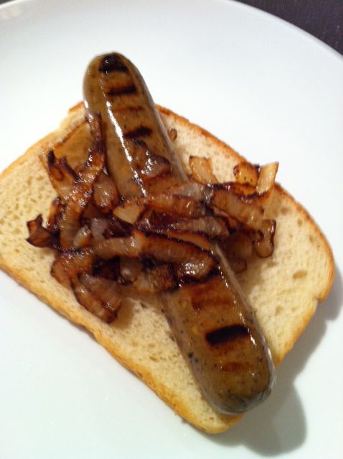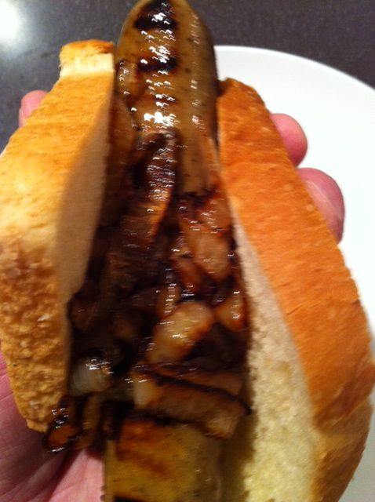

Classic Australian BBQ food, a “sausage sizzle” is a large get-together where lots of sausages are grilled up and served garnished with grilled onions on plain, white bread with ketchup or barbecue sauce. They’re commonly sold in stalls for fund-raising purposes at schools and community groups (the stalls themselves are called "Sausage Sizzles").

Ingredients for two servings:

2 slices boring ol’ white bread
1 medium-sized onion, sliced
2 sausages of any meat variety will do, except American hot dogs!
ketchup, to taste (Australians call it “tomato sauce”)
BBQ sauce, to taste
butter, to taste

Directions:
Barbeque the sausages and onions to your liking on an outdoor grill.
Butter the bread slices. Place a sausage diagonally across each bread slice and garnish with onions. Top with BBQ sauce or ketchup. Serve with a cold Foster’s lager!

