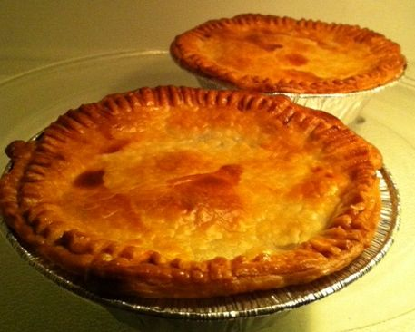 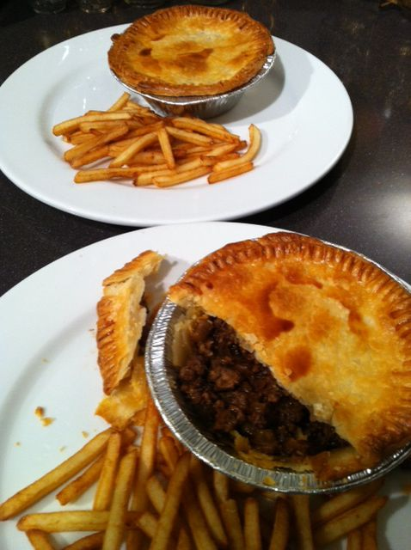 Aussie Meat Pies for Two

Ingredients:
1 Tablespoon of olive oil
1 medium-small, yellow/Spanish onion (a good cup’s worth), finely chopped
¾ pound ground beef sirloin, or other lean, ground beef
1½ teaspoons of cornstarch
⅓ cup beef stock or bouillon
1½ teaspoons ketchup (Aussies use a less-spicy and thinner “tomato sauce” for this)
1½ teaspoons Worcestershire sauce
½ teaspoon vegemite or substitute 1 vegetable-stock cube
2, 9-inch diameter sheets frozen, ready-rolled pie pastry, thawed
1 egg, beaten with 1 teaspoon water
salt, ground, black pepper, ketchup to taste

You’ll need two aluminum pie tins about 5” in diameter and 1” – 2” in height for this recipe (you know, the kind they sell frozen pot pies in!) which are available in most super markets.

Preparation:

Preheat oven to 425° F. Combine the cornstarch and 1½ teaspoons of cold beef stock; stir well and set aside.

Heat the oil in a medium-sized skillet over medium-high heat. Add the onion, season with a little salt and pepper; fry until nicely caramelized. Add the beef, cook until browned, stirring and crumbling well; season with a bit more salt and pepper. Add remaining beef stock, Worcestershire sauce, ketchup and Vegemite/vegetable cube to beef. Stir well to combine. Add the cornflower mixture and stir. Bring to a boil, reduce heat to low and simmer for 10 minutes uncovered. Remove from heat and cool to room temperature.

Tip a pie tin over on first pastry sheet and cut a circle around it. Repeat process to make another circle (these are the pie lids). Place pie tin on second sheet to cut a circle that's slightly larger than the tin (about ½” larger for the pie base). Repeat process to make another. Depending on what brand is used, you may either have to roll the second pastry sheet out with a rolling pin slightly larger than sold, or utilize the scraps from the first sheet and roll them all together to make a large sheet that will allow you to make the larger circles.

Press base pastry into pie tins and press up the sides. Fill with meat mixture. Brush rims with egg mixture. Place pie tops over meat. Use a fork to press edges to seal. Trim edges if necessary. Brush tops with more egg mixture (don’t bother cutting any steam-vent holes).

Place pies on a foil- or parchment-lined baking sheet and bake for 20 minutes, or until golden. Serve with ketchup, to pour over the top, and French-fried potatoes (“chips”)!

