Vindaloo Curry (requires overnight marinating – serves 2)

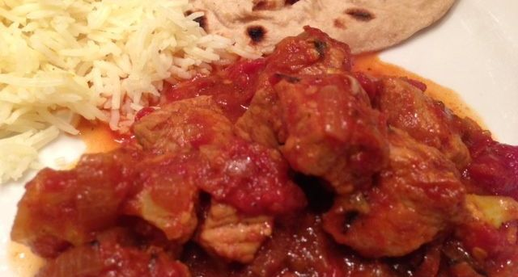

Mustard with turmeric, ginger, cinnamon, garlic, vinegar and brown sugar make vindaloo different from other Indian curry dishes. It is thought to have been inspired by the Portuguese, as they used a vinegar-garlic concoction to preserve pork that they shipped to Goa on India’s central west coast where the Portuguese ruled for over 400 years, leaving that part of India to this day with a strong Catholic-European tradition.

Ingredients:
½ pound pork loin, chicken, lamb or other meat, cut into pieces – shrimp vindaloo is also popular
1 small onion
14 ounces tomatoes, minced – I crush a can of Italian San Marzano tomatoes in it
1 clove garlic
6 - 12 dried, red chilies (to taste)
¼ teaspoon ground mustard
¼ teaspoon ground turmeric
¼ teaspoon ground ginger
1, 4” cinnamon stick, crumbled - or ⅛ teaspoon ground cinnamon
¼ teaspoon cayenne powder, or to taste
¼ teaspoon ground cumin
1 whole clove, or ⅛ teaspoon ground cloves
1 teaspoon white-wine vinegar
1½ teaspoons brown sugar
1 – 3 tablespoons olive or other vegetable oil
½ teaspoon ghee
½ teaspoon salt
½ teaspoon ground, black pepper

Preparation:
Roughly chop half of the onion, combine in a blender or food processor with garlic, dried chilies, mustard, turmeric, ginger, cinnamon, chili, cumin, cloves, cinnamon, salt, black pepper and sugar. Blend until smooth, adding enough oil to make runny.

Combine the meat in a bowl with spice mixture. Marinate for at least 4 hours, preferably overnight.

Slice the remaining onion. Melt ghee/oil in a saucepan over medium heat and sauté onion until nicely caramelized – at this point, you may add in some small potatoes (“aloo”) and/or cauliflower florettes (“gobi”) to caramelize with the onion.

Add the meat. Reduce heat to low, add the vinegar and tomatoes, cover (lid cocked to reduce sauce) and simmer for 45 minutes, or until the meat is tender, stirring occasionally.

