Sweet-and-Sour Vietnamese Pork with Pineapple and Vegetables (Muc Xao Khom)

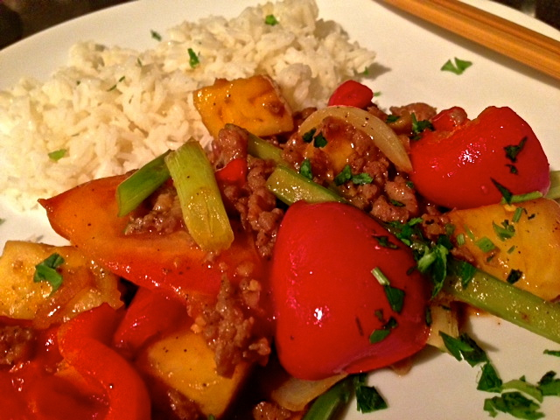

A lovely combination of fresh vegetables is used in this traditional, Vietnamese stir-fry. It can be made with any kind of pork. Recipes makes two servings.

Ingredients:
½ pound pork neck (use pork tenderloin if you can’t find any – I like using ground pork)
2 tablespoons sugar, plus 1 additional tablespoon (divided)
1 teaspoon cornstarch dissolved in 2 teaspoons water
1 tablespoon rice vinegar
1 tablespoon lemon juice
1½ teaspoons tomato paste
2 tablespoons fish sauce (see notes)
1 teaspoon freshly ground black pepper
2 cloves garlic, finely diced
1 smaller-sized or medium-sized tomato, sliced into 8 wedges
1 small red-bell pepper, seeded and cut into 1” x 1” cubes
8 ounces (½ pound) sweet pineapple, cut into bite-sized pieces
1 Asian shallot, minced (see notes)
1 smaller-sized onion, sliced into wedges
2 green onions/scallions, cut into 1 1/2-inch lengths on the diagonal
3 – 4 ounces Chinese celery, washed and thinly sliced into 1½” pieces (but see notes)
1 teaspoon fresh coriander (cilantro – optional for garnishing, but adds character), chopped
2 tablespoons sesame oil
Chopped, fresh chilies, to taste

Preparation:
Combine the first 2 tablespoons sugar, the corn flour/water mixture , vinegar, lemon juice and tomato paste in a cup or small bowl; mix it and set aside (this will be added to the wok later).
In another, larger bowl, add the remaining tablespoon sugar, the black pepper and the fish sauce, then stir until the sugar is thoroughly dissolved. Add in the pork and mix together well. Let it marinate for about 30 minutes.
Place a wok over high heat; add 1 tablespoon sesame oil followed by the garlic and pork. Stir-fry a few minutes, until browned (I like it slightly crispy), then take it out and set aside.
In the hot wok, add the remaining oil, the tomato wedges, bell pepper, frsh chilies (if including any) and the pineapple pieces; stir-fry a couple of minutes.
Return the fried pork mixture back to the wok, then pour in the prepared sauce. Stir, then add in the onions, shallots, spring onions, and celery; stir-fry for a further minute or two, until the sauce thickens.
Serve over jasmine rice garnished with a sprinkling of finely chopped cilantro.

Notes:
Chinese celery has very thin ribs, but tastes almost exactly like regular store-bought celery, so you can safely replace it with a rib of regular celery sliced thinly lengthwise. Asian shallots taste just like regular ones, in my opinion. Also, I find that fish sauce is too salty, so I replace it with soy sauce (just a personal preference).

