Vietnamese Stir-Fried Beef with Black & Green Peppercorns (Bo Luc Lac)

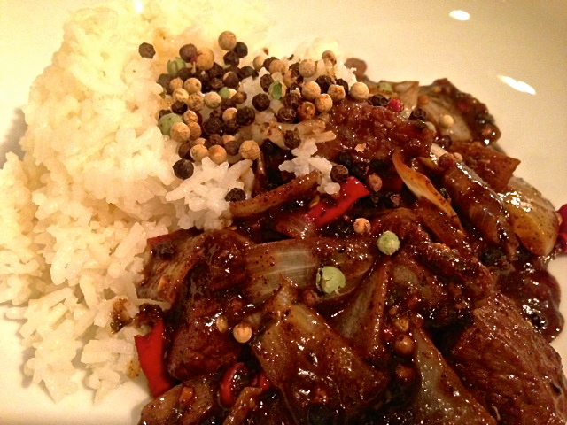 Recipe serves 2.

The French influence in Vietnam comes through in this recipe by way of butter in the stir-fry!

Ingredients:
8 ounces beef sirloin, cut into 1” cubes
3 tablespoons oyster sauce
1 tablespoon hot water
1 tablespoon sesame oil, for marinating
1 teaspoon sugar
1 tablespoon sesame oil, for frying meat
1 garlic clove, finely diced
½ small onion (about 2 ounces), cut into large dice
1 ounces (2 tablespoons) butter
1 – 2 tablespoons each course-ground black and green peppercorns, or just black
2 coriander (cilantro) sprigs to garnish (about 2 teaspoons), finely chopped
4 tablespoons soy sauce
2 – 4 chili peppers, finely chopped

Preparation:
In a medium-sized bowl, combine oyster sauce, hot water, 1 tablespoon sesame oil and sugar. Add the beef and marinate for at least ten minutes.
Heat a wok over high heat until smoking hot. Add 1 tablespoon sesame oil, then add the beef and seal on each side for a minute or so (the beef should be charred and the wok flaming hot!).
Add the garlic, onions, chopped chilies, ground black and green peppercorns, soy sauce and butter to the wok and continue to stir-fry until the liquid is reduced by at least 50% (you don’t want it to be too runny).
Serve with jasmine rice or baguette.

