Vietnamese Prawn & Mango Salad (Goi tôm xoai cat) – recipe makes 2 servings

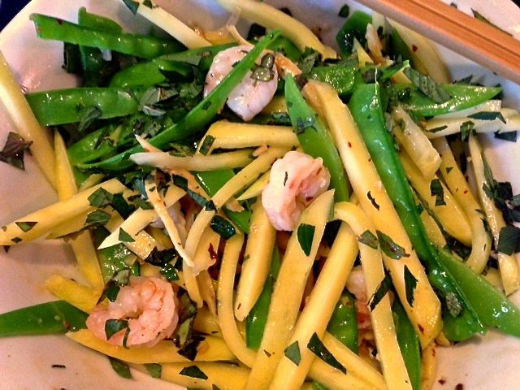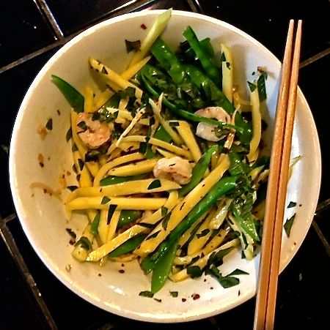

Ingredients:
8 ounces raw shrimp, peeled and deveined
2 ounces snow peas (mangetout)
10 ounces, semi-ripe (but not green) mango, peeled and julienned
1 cup mixed fresh mint, basil and/or perilla (Vietnamese)/zisu (Chinese)/shiso (Japanese) leaves –related to the mint family of herbs – chopped
2 small, Asian shallots, thinly sliced
1½” piece fresh ginger, peeled and julienned
2 cloves fresh garlic, minced
2 tablespoons lime juice
2 tablespoons sesame oil
Salt and ground, black pepper, to taste
Fresh or dried chilies, to taste

For the Dressing:
1½ teaspoons sesame oil
1 teaspoon Dijon mustard (the French influence over Vietnam)
1 teaspoon rice vinegar
Salt and ground, black pepper, to taste

Preparation:
Bring a saucepan of water to a boil. Add the snow peas and blanch for 1 minute. Drain, briefly refresh in cold water, then drain again. Slice lengthwise into two strips and place in a mixing bowl. Add the mango and most of the mint, reserving some mint for garnish. Set aside.

Whisk together the dressing ingredients. Season with salt and pepper. Set aside.

Heat a medium-sized (8”) skillet over medium heat. Add the 2 tablespoons sesame oil and sauté the shallots, garlic, ginger and chilies a couple of minutes until caramelized. Add the shrimp and stir-fry another couple of minutes until just cooked. Stir in the limejuice to deglaze the pan, then season with salt and pepper. Add the skillet mix to the bowl with the snow peas and mint, then pour over the dressing and toss until well combined. Transfer to a serving bowls and garnish with the remaining mint to serve.

