Vietnamese Ginger Chicken Stew (ga ban kho gung). Recipe serves 2.

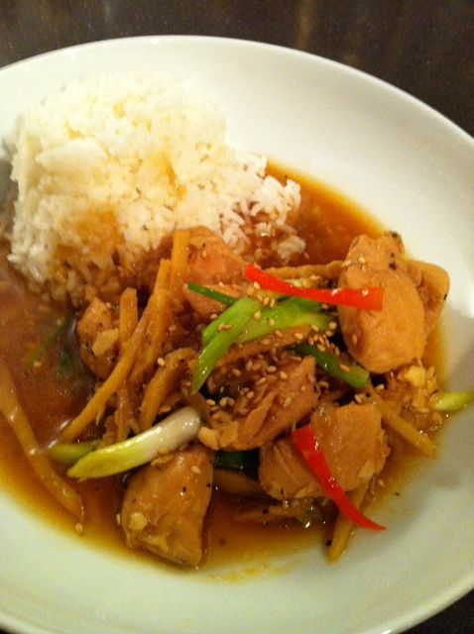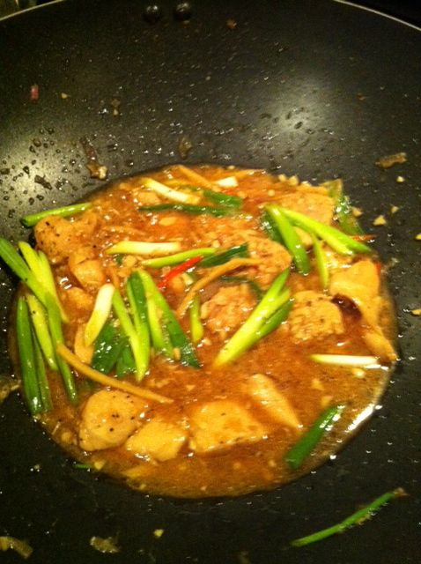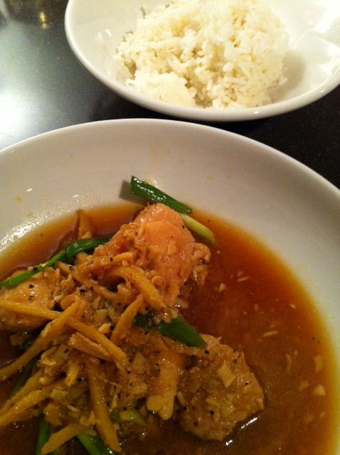

Ingredients:
3 tablespoons fish sauce (I substitute soy sauce or black-bean sauce)
1 teaspoon oyster sauce
1 tablespoon sugar
8 oz. chicken, chopped into bite sized pieces (I use boneless, skinless)
2 tablespoons ginger, finely minced or mashed, plus 4 – 5 oz. (about ½ cup) ginger julienned into very thin, ¼” x 2” lengths
2 tablespoons vegetable oil
2 tablespoons, garlic minced
1 small red shallot, minced
1 cup chicken stock
4 – 6 spring onions (scallions), sliced into 1½-inch lengths
a pinch cracked, black pepper
1 long chili, julienned
1 tablespoon toasted sesame seeds
Jasmine rice, to serve

Preparation:
In a mixing bowl, combine fish sauce, oyster sauce, and sugar. Mix well, then add the chicken and minced ginger, massaging the marinade into the flesh. Cover and place in the fridge to marinate for at least 30 minutes.
Bring a wok or saucepan to medium heat, then add oil and julienned ginger slices; stir-fry a few seconds, then add in the garlic and shallot, and cook until fragrant.
Turn the heat to high, then add the chicken, sealing all sides. Cover the chicken with the stock, pour in the remaining marinade and bring to the boil.
If making with bone-in and/or skin-on chicken, skim off any impurities until clear and cover the pan. Reduce the heat to low and simmer for 15 - 20 minutes. Add spring onions, the chili pepper and black pepper, stir and cook for a further minute. Transfer to a serving bowl and garnish with toasted sesame seeds. Serve with jasmine rice.

