Vietnamese Beef Phò for Two

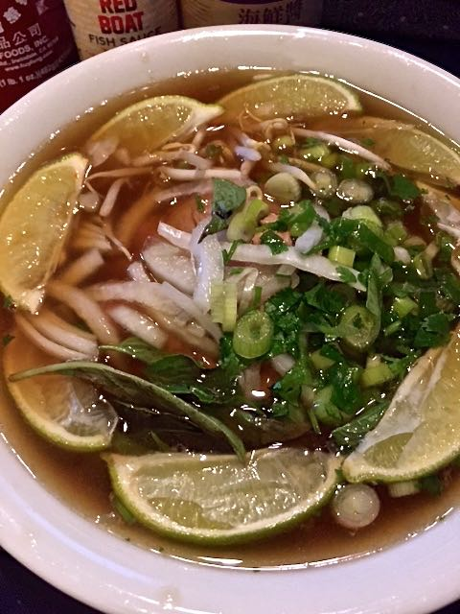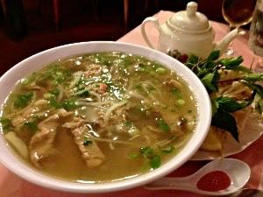

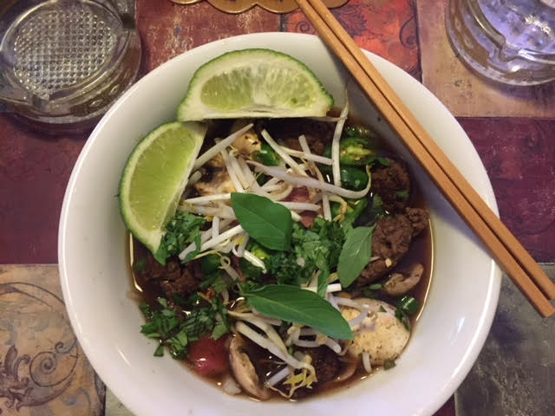

Ingredients:
1 6-ounce boneless strip steak or beef tenderloin, trimmed of fat
½ pound 85% lean ground beef
1 onion, quartered through root end
6 cups low-sodium beef broth
¼ cup fish sauce, plus extra for seasoning
1 2-inch piece ginger, unpeeled and sliced into thin rounds
1 cinnamon stick
1 tablespoon sugar, plus extra for seasoning
3 star anise pods
3 whole cloves
1 teaspoon salt, plus more if needed
½ teaspoon black peppercorns
4 ounces (⅛“ wide) rice noodles
2 tablespoons chopped fresh cilantro
2 scallions, sliced thinly
¼ cup bean sprouts
¼ cup fresh Thai or Italian basil leaves
2 limes, each cut into 8 wedges
Hoisin sauce
Sriracha sauce

Preparation:
Break ground beef into rough 1” chunks and drop in a large pot over medium heat. Brown on all sides, then add water to cover by 1” and bring mixture to a boil over high heat. Boil for 2 minutes, stirring once or twice. Drain ground beef in colander, then return beef to the pot.

Place 3 onion quarters in the pot with ground beef. Slice remaining onion quarter as thin as possible and set aside for garnish. Add broth, 1 cup water, fish sauce, ginger, cinnamon, sugar, star anise, cloves, 1 teaspoon salt, and peppercorns to pot and bring to boil over high heat. Reduce heat to medium-low and simmer, partially covered, for 45 minutes.

While broth simmers, place steak on large plate and freeze until very firm, 35 to 45 minutes. Once firm, trim off the hard knobs of fat and cut against grain into ⅛” thick slices. Return steak to plate and let come to room temperature before serving.

Pour broth through colander set in a large bowl. Discard solids, reserving the hamburger chunks. Strain broth through fine-mesh strainer lined with triple thickness of cheesecloth into the pot and season with extra sugar and salt (broth should taste over-seasoned). Cover and keep warm over low heat.

When ready to eat, place the noodles in a medium-sized container and cover with really hot tap water. Soak until noodles are pliable, 10 to 15 minutes; drain noodles. Meanwhile, bring 2 quarts water to boil in another large pot. Drain the noodles, add into the boiling water and cook until almost tender, 30 to 60 seconds. Drain immediately and divide the noodles evenly between two bowls.

Bring broth to rolling boil over high heat. Divide raw steak slices and the chunks of browned ground beef among individual bowls, shingling the slices on top of noodles. Pile reserved onion slices on top of steak slices and sprinkle with cilantro and scallions. Ladle hot broth into each bowl directly over the beef so as to cook it. Garnish with bean sprouts, basil leaves and lime wedges. Serve immediately with hoisin, Sriracha, and extra fish sauce separately.

