Turkish Chicken for Two

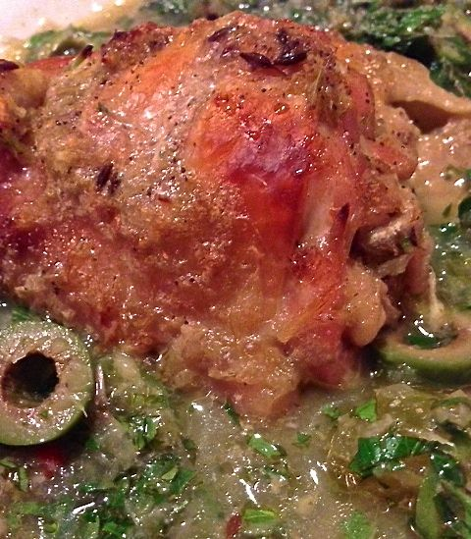

Turkey’s Asian side really comes out in this dish with plenty of garlic, ginger and chili pepper.

Ingredients:
2 whole chicken thighs, skin on, bone in
1” - 2“ piece ginger, peeled and roughly sliced
4 – 6 cloves garlic, peeled and roughly sliced
1 medium-large white onion, peeled and quartered
1 rib celery, roughly sliced
Salt and ground, black pepper, to taste
Water or chicken broth – enough to cover the chicken in a pot
½ teaspoon whole cumin seeds, toasted in a dry pan
1 bay leaf
2 – 4 fresh or dried red chilis, minced
Olive oil, enough to drizzle over the chicken
¼ cup fresh, chopped flat-leaf parsley
¼ cup fresh, chopped cilantro
¼ cup sliced green, Mediterranean olives
Juice of 2 lemons (4 tablespoons)

Preparation:
Preheat oven to 350° F.

Give the ginger and garlic a whirl in a food processor until thoroughly chopped. Add in the onion and continue pulsing until it is also thoroughly chopped. Pop in the celery, season lightly with salt and pepper, and pulse until chopped and you have a thick marinade.

Cut two slices in the top of the skin of each thigh. Place them in a large saucepan on the stove and season lightly with salt and pepper. Pour the sauce from the food processor in over the chicken. Pour in just enough chicken broth and/or water to cover the chicken pieces. Add in the toasted cumin, bay leaf and chili. Bring to a gentle simmer, uncovered, for 20 minutes.

After the 20 minutes of simmering, remove the chicken to a shallow baking pan skin-side up. I actually put them in a glass pie dish. Pour the sauce evenly around the chicken, drizzle the chicken with olive oil and put it in the preheated oven for 25 – 30 minutes, or until golden brown.

Remove the chicken to serving plates. To the hot sauce in the baking pan, add the parsley, cilantro, olives and lemon juice; stir well and pour evenly on the plated around the chicken. Make sure you remove the bay leaf before serving.

Serve with warmed flat bread on the side.

