Traditional Indian Curry Recipe (taught to me years ago in Milwaukee by an old friend from Pakistan)
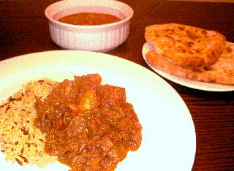 Serves 2 to 4 persons.
Ingredients:
1 to 1½ pounds chicken, lamb, other meat of choice, shrimp, lobster, tuna or other fish (see note below)
1 large onion, minced
1 large tomato, finely diced (or one, 14.5-oz. can whole tomatoes, crushed by hand)
2 to 3 cloves fresh garlic, crushed
1 tablespoon garam masala Indian spice (available at Indian-food shops)
1 teaspoon turmeric powder
1 teaspoon hot/cayenne (red chili-pepper) powder, or to taste - we like it hot!
½ teaspoon salt
½ teaspoon ground coriander
¼ teaspoon ground cardamom
¼ teaspoon ground cumin
¼ teaspoon ground cinnamon
¼ teaspoon ground, black pepper
1 ground clove
⅛ teaspoon All Spice
2 servings cooked, Basmati rice
Cooking oil

Preparation:
Heat enough oil to cover the bottom of a large, deep skillet. If making the recipe with meat, remove any bones and cut into bite-sized pieces. Brown the meat in the oil, then set it aside. If making the recipe with seafood, go to the next step before adding to the pan.

Add the onion to the oil in the pan and fry until caramelized. Add the spices and cook one minute, then add in the garlic and tomato; let it simmer and reduce down to a soupy mash, then add the seafood or the browned meat back in with water enough to cover the contents of the pan. Boil on med-high heat uncovered until water is fairly well evaporated and it’s thickened up nicely.

Serve over the rice with naan, chapatti or other Indian flat bread, using the bread in lieu of flatware to scoop up the curry and rice.

Note:
We love to make curried beef at home using sliced skirt steak, and it is delicious)! Shrimp should be shelled, cleaned and deveined, and it should not be added in until only about the last five minutes so that it does not get overcooked and rubbery. You may substitute the meat and seafood with half a pound of peeled, diced potatoes, half a pound of chopped cauliflower and about a cup of frozen peas to make a popular vegetarian curry called "aloo gobi." Boil the potatoes and cauliflower for 10 minutes in unsalted water and drain while you simmer the tomatoes and onion, then add them in with the peas at the end of the recipe above when you would add in the browned meat or seafood.

