Thai Beef with Peppers for Two

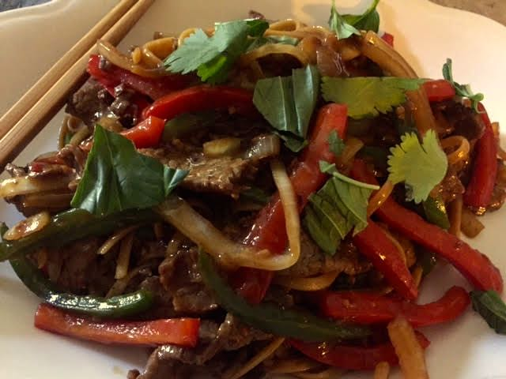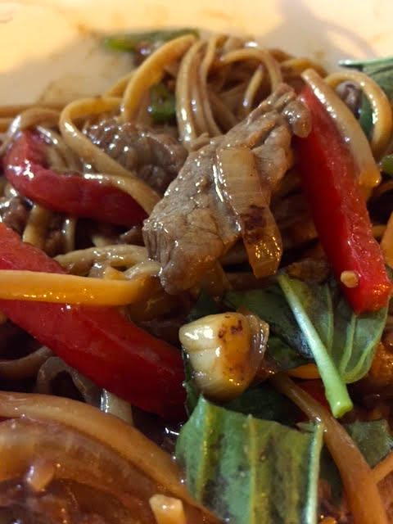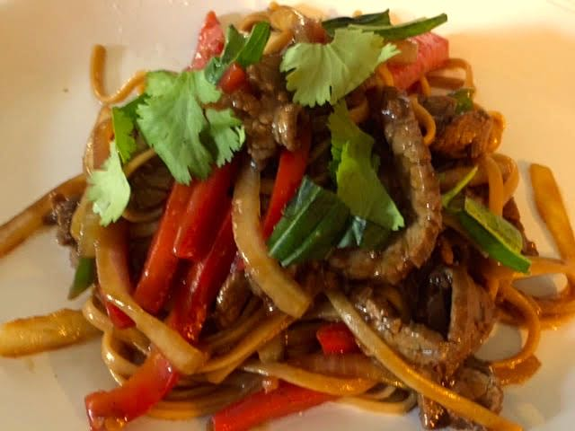

Ingredients:
- ½ pound flank steak, sliced very thin against the grain (freeze it 30 minutes first)
- 4 ounces pad Thai rice noodles or linguine
- ½ a medium or a small yellow onion, thinly sliced
- ½ or a small, red bell pepper, cored and sliced the same as the onion
- 1 fresh jalapeño or Serrano chile, sliced just like the onion and bell pepper
- ¼ cup soy sauce
- 5 teaspoons Shaoxing rice wine or dry sherry
- 1 tablespoon cornstarch
- 1 tablespoon packed brown sugar
- 1½ teaspoons minced fresh ginger
- ½ teaspoon red chili paste or a few dashes red chili oil
- 2 cloves garlic, minced
- 1 lime, halved
- 1 tablespoon peanut, Asian toasted sesame or other vegetable oil
- Fresh basil and cilantro leaves, for garnish

Preparation:
Cook the noodles according to the package directions. In a small bowl, mix the soy sauce, wine or sherry, cornstarch, brown sugar, ginger, chili paste, garlic and the juice of half the lime. Pour a third of the marinade into a bowl with the sliced beef and toss to coat. Reserve the rest of the marinade.

Heat 1½ teaspoons of the oil in a wok or large skillet over medium-high to high heat. When it is very hot, throw in the onions and cook for a minute or so. Add the bell pepper and chile. Cook for a minute, then remove the vegetables to a plate.

Add the remaining oil into the hot wok. Add the meat mixture and stir-fry for 45 seconds to a minute, then add the onions and peppers back into the wok. Reduce the heat to low. Pour in the remaining marinade and stir. Allow to simmer on low for a few minutes so the sauce can thicken. Turn off the heat. Drain the noodles, reserving ½ cup of the boil-water, then toss them with the meat and vegetables. Stir in some of the boil-water, if needed to thin the sauce. Top with basil and cilantro leaves and serve immediately with a squeeze of the remaining lime half.

