Tarka Dal

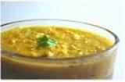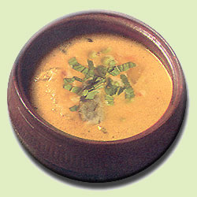 A traditional side-dish served in most parts of India.

INGREDIENTS
- 9 ounces chana dal (dried yellow split peas), rinsed until the water runs clear
- 1 3/4 pints water
- 3 tablespoons vegetable oil
- 1 tablespoon cumin seeds
- 1 small onion, chopped
- 3 to 4 whole green chiles, pricked with a knife
- 1 (3/4-inch) piece fresh ginger, peeled and cut into thin strips
- 3 cloves garlic, peeled and left whole
- 3 tomatoes, chopped
- 3/4 teaspoon ground turmeric
- 3/4 teaspoon garam masala
- 1 1/2 teaspoon ground coriander
- Kosher salt and freshly ground black pepper
- Handful chopped fresh cilantro leaves

DIRECTIONS

Put the lentils and water into a pan, stir well and bring to the boil. Skim off any froth that forms on the surface of the water with a spoon. Cover the pan with a lid and reduce the heat to a simmer. stirring regularly, for 35 to 40 minutes, or until the lentils are just tender, adding more water as necessary.
When the lentils have cooked through, remove the pan from the heat, and use a whisk to break down the lentils. Set the mixture aside to thicken and cool.
Meanwhile, heat the oil in a pan over a medium heat. Add the cumin seeds, and fry for 20 to 30 seconds, or until fragrant. Add the onion, chiles, and ginger, and fry for 4 to 5 minutes, or until golden brown.
Blend the garlic and tomatoes to a puree in a food processor. Add the puree to the pan, and stir well to combine. Add the turmeric, garam masala, coriander, and 3 1/2 ounces of water to the pan, and stir well to combine. Season the mixture with salt, to taste, and simmer over a medium heat for 15 to 20 minutes, or until the oil from the sauce has risen to the surface of the sauce.
Add the cooked lentils to the sauce, and stir well, adding more water as necessary, to loosen the mixture. Bring the mixture to a boil, and season, to taste, with salt, and freshly ground black pepper. Stir in the chopped cilantro just before serving. If this dish is not sour enough for you, add a squeeze of lemon juice. If you are a garlic lover, you can add another 2 cloves of garlic. NOTE: Do not use plum tomatoes for this (they’re too sweet)!

