Tandoori Chicken (serves 2 - recipe needs to marinate at least 8 hours or overnight).

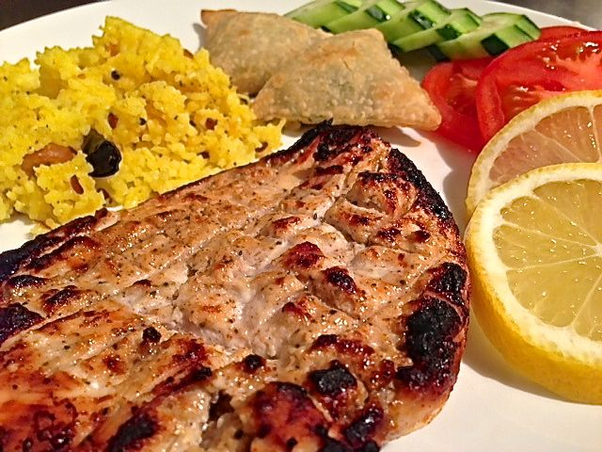

Ingredients:
½ pound chicken, boneless, skinless
6 ounces plain yogurt
1 tablespoon fresh lemon juice or malt vinegar
2 cloves garlic, minced
1” long knob ginger root, peeled and grated or crushed
1½ teaspoons ground cumin
½ teaspoon ground coriander
½ teaspoon cayenne pepper
⅛ teaspoon ground cardamom
⅛ teaspoon ground cloves
¼ teaspoon ground, black pepper
1 teaspoon salt, or to taste
Fresh cilantro sprigs for garnish
Slices of cucumber, red onion, tomato and lemon, for garnish

Preparation:
Prick the flesh of the chicken all over with a fork. Then, using a sharp knife, cut slashes in the flesh to allow the marinade to penetrate. Place the chicken in a large, shallow dish (I use a Ziploc bag).

Combine the yogurt, lemon juice or vinegar, garlic, ginger, cumin, ground coriander, cayenne pepper, cardamom, cloves, black pepper and salt. Stir until mixed well, then pour the mixture over the chicken and rub it into the flesh, turning the chicken several times. Cover and refrigerate 8 hours or overnight (do not marinate for longer than 2 days). Remove the chicken from the refrigerator at least 30 minutes before cooking.

OUTDOOR GRILLING: Place the chicken pieces on a well-oiled grill rack and grill, covered, with the vents open, turning 3 or 4 times, 45 minutes or until the juices run clear when a piece is pierced near the bone with a knife.

INDOOR PREPARATION: Line a baking sheet with foil; place chicken parts on a greased wire rack in the baking sheet. Bake at 325° F. until breast meat registers about 125° F. and thigh meat registers about 130° F. (45 minutes – 1 hour). Flip chicken and broil 8 – 15 minutes 6 inches under heating elements until breast meat registers about 165° F. and thigh meat registers about 175° F.

