Szechuan Style Spareribs

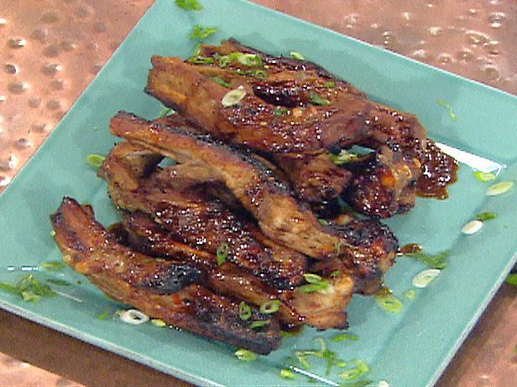 Makes 6 servings.

Ingredients:

1 (4 pound) slab pork spareribs
¼ cup plus 2 tablespoons rice wine
¼ cup plus 2 tablespoons soy sauce
¼ cup plus 2 tablespoons hoisin sauce
3 tablespoons packed brown sugar
2½ tablespoons minced garlic
2½ tablespoons chili garlic sauce
1¼ teaspoons Chinese five-spice powder
3 tablespoons honey
1½ teaspoons sesame oil

Directions:

Using a sharp knife, cut the slab of ribs between the bones into individual ribs. Place in a stock pot or large soup pot and add enough cold water to cover by 2 inches. Bring to a boil, reduce heat to a steady simmer, and cook until the ribs are tender, 1 to 1½ hours, skimming the surface of any scum that rises to the top while cooking. Remove the ribs to a large bowl and set aside to cool completely. (Reserve the pork stock for another purpose.)

Combine the rice wine, soy sauce, hoisin, brown sugar, garlic, chili garlic sauce and five-spice powder and whisk to blend. Pour half of the marinade over the cooled ribs and toss to coat. Cover with plastic wrap and refrigerate, stirring occasionally, for 2 hours or up to overnight. Reserve the remaining half of the marinade in a non-reactive container and refrigerate.

Preheat the broiler and position a rack in the upper third of the oven.

To the remaining half of the marinade, add the honey and sesame oil and whisk to combine. Remove the ribs from the refrigerator and transfer to an aluminum foil-lined baking sheet. Brush with some of the remaining marinade-honey mixture and broil for 4 to 5 minutes, or until the ribs are crispy on the upper edges. Remove the ribs from the oven and turn to the other side, brush with some of the remaining marinade mixture and broil again for about 4 minutes. Remove from the oven and allow to cool slightly. Serve hot.

