Szechuan Pork Stir-Fry in Garlic Sauce for Two

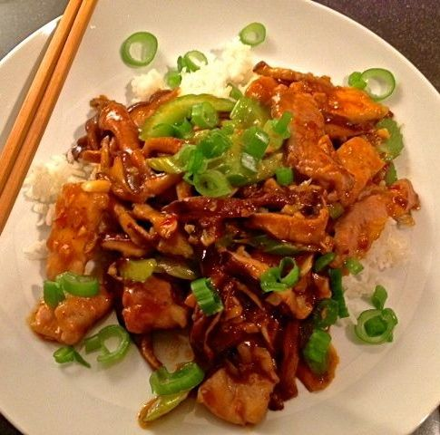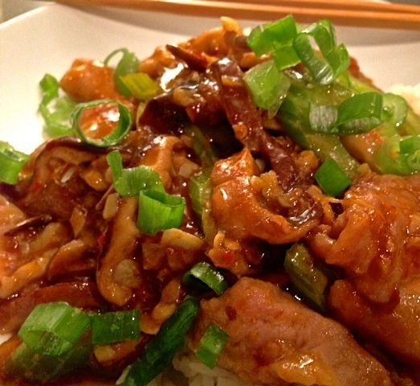

A classic Chinese-restaurant staple menu selection, the unusual use of baking soda in this recipe to tenderize the pork makes it quite tender and silky.

Ingredients:
8 ounces country-style, pork sparerib
¾ teaspoon baking soda
⅓ cup water
⅓ cup ham or chicken broth
4 teaspoons sugar
4 teaspoons soy sauce
3 teaspoons Chinese black vinegar, or may substitute a mixture of half rice vinegar and half balsamic vinegar
2 teaspoons shaoxing rice wine or dry sherry
2 teaspoons Asian sesame oil, plus a little more for frying
1½ teaspoons beef broth
1½ teaspoons ketchup
1½ teaspoons cornstarch
4 ounces shitake mushrooms, stems removed and thinly sliced
1 rib celery, sliced on the bias into ¼“ thick pieces
1 scallion, white part minced, green part sliced thinly into rings for garnishing later
3 – 5 cloves garlic, minced
4 teaspoons Asian broad-bean chili paste, or may substitute with 2 teaspoons of either sriracha chili sauce or chili-garlic sauce
1½ teaspoons shaoxing rice wine mixed with 1½ teaspoons cornstarch

Preparation:
Slice the pork very thinly into ¼“ pieces. Mix the baking soda with the water; add in the pork and allow to marinate 15 minutes.

To make the sauce, thoroughly whisk together the broth, sugar, soy sauce, black vinegar, rice wine or sherry, sesame oil, beef broth, ketchup and cornstarch.

Combine the garlic, minced scallion whites and broad-bean sauce (or substituted chili sauce) in a bowl.

Heat up a little sesame oil in a 12” non-stick skillet on high heat until just smoking. Drain the pork and rinse the excess marinade off. Pat it dry and put back in the bowl and coat it thoroughly with the wine-cornstarch mixture.

Cook down the mushrooms in the hot skillet until slightly wilted, glossy and tender. Add in the celery and stir-fry it a few minutes until darker and crisp-tender. Remove the vegetables to a bowl.

Put about a tablespoon more of oil in the pan. Lower the fire to medium-low, then fry the chili-paste/garlic/scallion mixture a few minutes.

Bump the heat back up to high and add in the pork; stir-fry a few minutes until cooked through and browned. Mix in the sauce. Add back in the vegetables and stir thoroughly.

Plate the dish, garnish with the scallion greens. Serve with steamed jasmine rice.

