Spicy Ginger Beef with Bok Choy and Bean Sprouts for Two

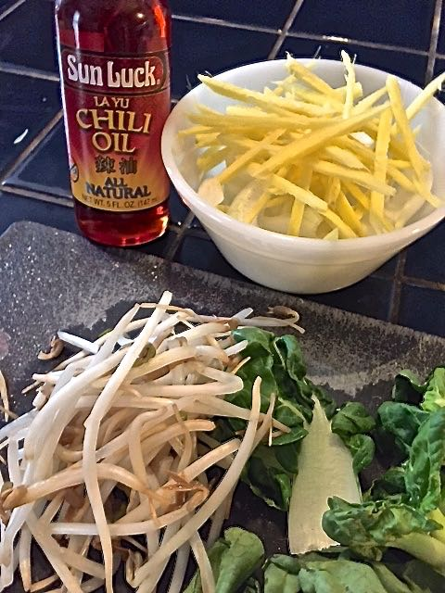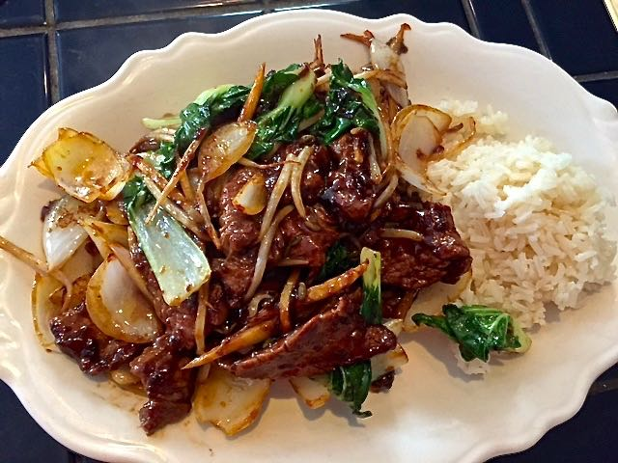

Ingredients:
½ pound beef flank steak, sliced into 1” pieces on the diagonal
3 tablespoons soy sauce, plus an additional two tablespoons for the sauce
1 tablespoon Cornstarch, plus 2 teaspoons (divided)
1 tablespoon shaoxing rice wine or dry sherry
1 teaspoon minced fresh ginger root
1 clove garlic, minced
4 ounces bok choy cabbage (a quarter of a big stalk), or same weight baby bok choy
2 tablespoons Chinese chili oil, divided
1 small onion, cut into ½“ square pieces
2” straight piece of fresh ginger root, peeled and finely sliced into matchsticks (see note)
¼ cup bean sprouts
1 cup cooked jasmine rice – ½ cup for each serving

Preparation:
Cut beef across grain into thin slices. Combine 3 tablespoons soy sauce, cornstarch and wine/sherry with minced ginger and garlic in medium bowl; stir in beef (I mix it all up in a Ziploc bag). Let marinate at least 30 minutes.

Meanwhile, get rice started. Then, combine the 2 teaspoons cornstarch with 2 tablespoons soy sauce; set aside. Separate and rinse bok choy; pat dry. Cut leaves crosswise into 1" strips, separating stems from leaves.

Heat 1 tablespoon oil in hot wok or 12” non-stick skillet over high heat. Drain marinade from beef and add in; stir-fry until caramelized, then remove from pan to the side. Heat remaining 1 tablespoon oil in same pan. Add onion and slivered ginger; stir-fry until onion is translucent and ginger is golden. Add bok choy and bean sprouts; stir-fry 1 minute longer. Add beef back in with the soy sauce mixture; cook and stir until sauce boils and thickens. Serve immediately over ½ cup of the steamed rice per each serving.

Note:
It’s easiest to slice very thin sticks of ginger by first cutting it into wide ⅛“-thick slices, then laying them flat on your cutting surface to slice them into ⅛“-thick sticks.

