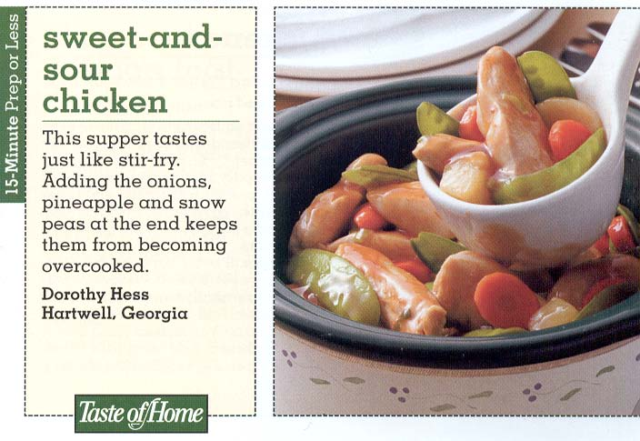
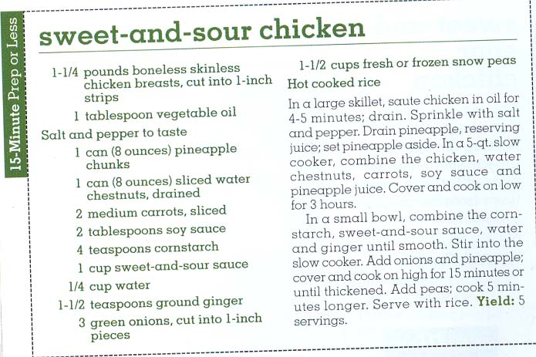

Jeff’s Notes: I replace the carrots with 1 red bell pepper, sliced into large pieces. I also replace the green onions with half a medium-sized, sweet Vidalia onion, cut into large pieces (about 2” big). But I do garnish with some cut green-onion tops at the end of the cooking time, if I have any on hand.

