Prawns in Apple-Basil Curry by Bal Arneson (modified).
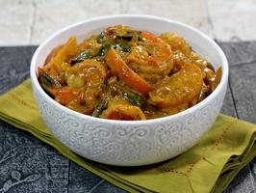 Recipe serves 2, but can be doubled.

INGREDIENTS:

2 tablespoons cooking oil
10 large prawns, peeled, deveined and tails removed and reserved to make stock
Salt and pepper
1 tablespoon butter
1 tablespoon minced ginger
1 cooking apple, peeled, cored and sliced thinly
1 small onion, minced
1 teaspoon garam masala
¼ teaspoon coriander seeds, crushed
¼ teaspoon smoked paprika
¼ teaspoon turmeric
1/8 teaspoon red chili flakes
½ cup apple cider
¼ cup shrimp stock (boil the shrimp heads/shells/tails with the vegetable pairings in salted water for 10 minutes; strain through a fine sieve)
¼ cup coconut milk
1 small bunch fresh basil leaves, stems removed, plus a few sprigs for garnish
Rice, for serving

DIRECTIONS:

Add the oil to a large skillet over medium-high heat. When hot, add the prawns, sprinkle with salt and pepper and sauté until the prawns turn bright red and the edges are golden, 3 to 5 minutes. Remove and keep warm.
Add the butter to the prawn pan and when it begins to foam, add the ginger, apple slices and onion. Cook until the apples are caramelized, about 10 minutes, stirring to break up the apple chunks. Add the garam masala, coriander seeds, paprika, turmeric, chili flakes and a pinch of salt and cook for 1 minute. Pour in the apple cider and shrimp stock, then reduce by one-third, about 10 minutes. Pour in the coconut milk, stir well and continue to reduce until it thickens and coats the back of a spoon; this should take 3 to 5 minutes. Add the prawns and stir to heat through. At the last minute, stir through the basil leaves until they are just wilted. Serve the curry with rice and garnish with fresh basil sprigs.

