Peanut Noodles with Flank Steak and Vegetables
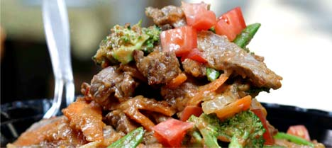

Ingredients:

8 ounces soba noodles or whole wheat spaghetti
1 pound flank steak
3 tablespoons olive oil
1 (12-ounce) bag fresh vegetable medley, such as carrots, broccoli, snow peas
½ cup smooth natural peanut butter
2 tablespoons soy sauce
2 teaspoons minced garlic
1½ teaspoons chile-garlic sauce*, or to taste
1 teaspoon minced fresh ginger
Diced tomatoes for garnish

Preparation:

Cook pasta according to package directions. In a large sauté pan, add 3 tablespoons olive oil over medium-high heat. Sauté flank steak approximately 4-5 minutes on each side until done. Remove steak to a cutting board.

Add vegetables to sauté pan and sauté for 2-3 minutes until tender. Remove pan from heat, add remaining ingredients, and allow to cool. Slice flank steak to bite-size pieces. Add steak and pasta to cooled vegetable mixture. Toss to coat well. Serve warm or chilled, topped with diced tomatoes.

*Chile-garlic sauce (or chili-garlic sauce, or paste) is a blend of ground chiles, garlic, and vinegar and is commonly used to add heat and flavor to Asian soups, sauces, and stir-fries. It can be found in the Asian section of large supermarkets and will keep up to 1 year in the refrigerator.

Note: This recipe can be made ahead and refrigerated for up to 2 days. To serve, remove from refrigerator and stir in 2 tablespoons warm water per portion; serve cold or reheat in microwave.

