Paneer (Home-made Indian Cheese) – recipe yields 1 lb. (enough for 2 main servings or 4 side-dishes).

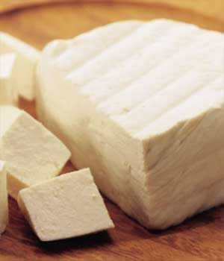

This is a very traditional component to many, classic Indian dishes. You need cheesecloth to make this!

INGREDIENTS:

½ gallon (4 pints) whole milk (may use 2%, if you like)
½ cup vinegar – use a good white wine vinegar!
1 TBS. finely-ground salt (do not use a coarse salt, like kosher)
1 tsp. ground, white pepper

PREPARATION:

Pour the milk into a large, deep pot; mix it well with the salt and pepper. Gradually bring it to a boil over medium-high heat (keep a close eye on it so as to prevent it from over boiling all over your range top!). Mind that you stir it occasionally and, when the milk starts to boil, and it foams and begins to rise in the pot, add the vinegar and stir until the mixture separates into solids and liquid.

Drain the mixture through a cheesecloth-lined colander or sieve set over a large bowl. Wrap the ends of the cheesecloth around the curd and put a heavy weight on it such as a cookie jar or rice container.

Place the mixture in the refrigerator and let the water completely drain for at least one hour, or overnight for a firmer paneer.

Remove the paneer from the cheesecloth; use the paneer immediately, or refrigerate in a covered container for up to five days.

