Perfect Palak Paneer – recipe serves 4

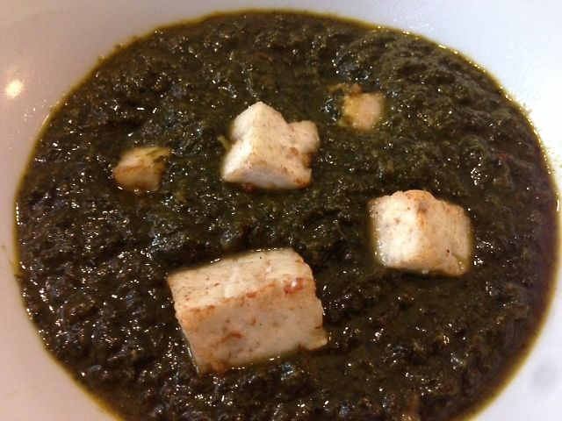

This Indian dish combines fresh spinach and cheese in a creamy curry. Use paneer – it’s easy to make and can be found in any Indian grocery. It’s wonderful with basmati rice or naan (Indian flat bread). The key is in the spices, which you can find at an Indian grocery.

Ingredients:
6 tablespoons ghee or vegetable oil
2 cloves garlic, chopped
3 teaspoons Indian ginger paste or grated fresh ginger root, divided
2 – 4 dried red chili peppers
½ cup finely chopped onion
2 teaspoons ground cumin
1 teaspoon ground coriander
1 teaspoon ground turmeric
¾ cup (6 – 8 ounces) crème fraîche or sour cream
3 pounds fresh spinach (that’s about 5 – 6 bunches), washed
1 large tomato, roughly chopped for the food processor or blender
7 – 8 ounces Indian paneer cheese or firm ricotta cheese, cut into 1” cubes
Salt, to taste (I season everything as I go)

Preparation:
In a large saucepan heat 3 tablespoons of olive oil and sauté garlic, 1½ teaspoons of the ginger, red chilies (optional ingredient) and onion until brown. Mix in the cumin, coriander, turmeric and sour cream (add more or less to achieve desired creaminess). Add the spinach, handfuls at a time until it is cooked down and the liquid is mostly reduced/evaporated. Remove from heat and allow to cool slightly.

Pour spinach mixture into a blender or food processor and add the tomato and the remaining ginger. Blend for 15 to 30 seconds, or until the spinach is finely chopped. Pour back into the saucepan and keep warm over low heat.

In a medium frying pan, heat 3 tablespoons of ghee or vegetable oil over medium heat and fry cheese until browned; drain and add to spinach. Cook for 10 minutes on low heat. Season with salt to taste.

