PANEER PAKORA
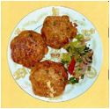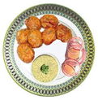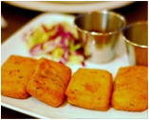
Recipe of PANEER PAKORA
Ingredients: | Unit | Quantity
Water | cup | 1/2
Chickpea Flour (Besan) | cup | 1
Chopped Green Chillies (Jalapeno) | number | 1-2
Oil | tsp | 2
Paneer | grams | 250
Red chili powder | tsp | 1/2
Salt | tsp | 1 1/2
Preparation:
• Mix first set of ingredients well.
• Beat in a blender for 4-5 minutes to incorporate air (this will make the batter fluffier).
• Let batter rest 1/2 hour in a warm place
• Cut the paneer into thick cubes.
• Sprinkle little salt, chili powder on the cubes
• Deep fry in skillet in oil that is heated to 375°.
• Drain on paper towels and serve immediately.
• Serve the paneer pakora with coriander or mint chutney

