Meatball Curry Serves 4

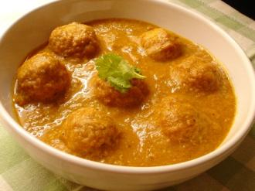

Ingredients:

- For the meatballs...
- 2 Tablespoon Curry Powder
- 1 Teaspoon Garam Massala
- 1 Teaspoon Cumin powder
- 1 Teaspoon Chilli Powder
- Juice 1 lemon
- 8 cloves garlic - crushed
- 2Lbs Lamb Mince
- Vegetable Oil

- For the sauce...
- 1 Cup thick yogurt
- Half an onion finely chopped
- 1 inch grated ginger
- 2 cloves garlic
- 1 tablespoon Garam Massalla
- 2 teaspoons tamarind concentrate/paste
- 1 small green chilli finely chopped
- 1 teaspoon Turmeric powder

Cooking method for Meatball Curry

Mix the meatball ingredients together well. Mould into meatball shapes and fry with a little vegetable oil to seal on all sides. Set aside. Fry the onion and chopped chili in oil gently until golden, add ginger, sliced garlic, garam massalla, tamarind, turmeric; stir fry a minute or so, then add the meat balls and stir fry until cooked through. Pour over the yogurt and give a half-hearted stir. Serve with wedges of lemon as garnish.

