Lamb Madras – this spicy recipe is magical (makes 2 servings)!

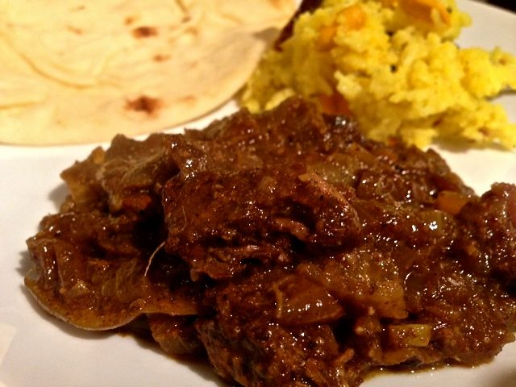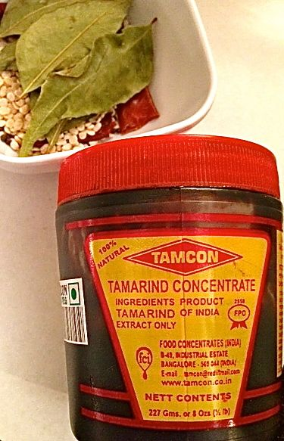

Ingredients:
¾ teaspoon ground turmeric
½ pound lamb meat (I use leg of lamb), trimmed of all fat and cut into 1½” cubes
¼ cup ghee (clarified butter), melted
3 tablespoons vegetable oil
2 medium-large onions, sliced ¼” thick
8 ounces coconut milk
1 cup water, divided in half
½ teaspoon fennel seeds
4 cardamom pods, slightly crushed open
4” – 5” of cinnamon stick
¾ teaspoon garam masala
½ teaspoon sugar
1½ teaspoons warm water
1½ teaspoons tamarind paste or syrup (tastes like sour prunes!)
A dash of salt, ground, black pepper and granulated garlic powder

For the Curry Paste
4½ teaspoons coriander seeds
1½ teaspoons cumin seeds
½ teaspoon salt
5 whole dried red chili peppers
6 fresh curry leaves (dried will do just fine)
3 tablespoons garlic paste
1 tablespoon ginger paste

Preparation:
To make the curry paste, toast the coriander seeds over medium heat until they begin to turn brown and pop. Repeat the toasting process with the cumin seeds, then with the dried red peppers. Transfer each ingredient to a food processor or spice grinder as you finish. Add the salt and curry leaves, and grind to a fine powder. Mix with the garlic and ginger to form a thick paste. This is where part of this recipe’s magic is. The smell of this paste is out of this world!

Toast the fennel seeds as above and set aside.

Sprinkle the turmeric, salt, pepper and garlic powder over the lamb, stirring lightly to coat. Heat a large saucepan oven over medium-high heat with just a wipe of ghee. Brown the meat and remove to the side.

In the hot pan, melt the rest of the ghee with the vegetable oil; cook the onions until golden brown, about 10 minutes. Stir in your curry paste and fry for 1 minute.

Stir in the meat and fry for 1 minute more. Pour in just a little more than half of the coconut milk and ½ cup of water; bring to a boil, then reduce the heat to low. Simmer for 10 minutes.

Stir in the remaining coconut milk and ½ cup water, along with the cardamom pods, cinnamon stick, and toasted fennel seeds. Cover with the lid ajar and return to a simmer, cook for about 1½ hours until the lamb is tender. Stir occasionally and thin with water if the sauce becomes too thick while cooking. Here’s where the rest of this recipe’s magic happens – you’ll know what I mean when you see how the lamb, onions, spices, herbs and the coconut milk turn into an unexpected, dark and lovely, rich, aromatic sauce. It just blows my mind every time!

When the lamb is tender, stir in garam masala, sugar, and the tamarind paste dissolved in the 1½ teaspoons warm water; cook 5 minutes longer, or until the sauce thickens. Remove the cinnamon stick and the remains of the cardamom pods before serving.

