Lao Buffalo & Pork Patties

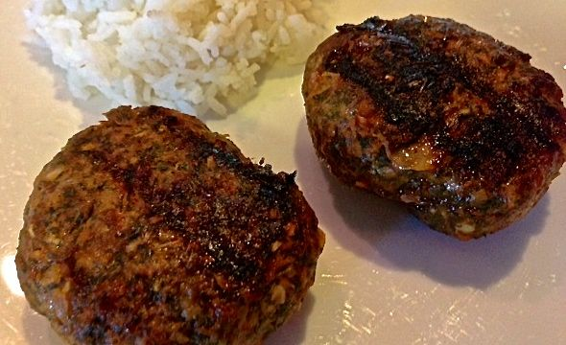

Laotians love their sticky rice and they love to put dill in their recipes. This recipe calls for both; the dill goes into the little patties before grilling and then they are served with the rice on the side.

Ingredients:
4 ounces ground buffalo (bison)
4 ounces ground pork
2 Asian shallots, minced
2 stems lemon grass (white parts only – about the first 2” - 4” of the base), thinly sliced
½ teaspoon salt
½ teaspoon sugar
1 teaspoon ground red chili powder (cayenne)
1 teaspoon fish sauce
1 scallion, roughly chopped
3 tablespoons chopped dill – you can use the same amount of dried dill
½ cup sticky rice, to serves with the grilled patties (see note)

Preparation:
The traditional way to make this is by first pounding the shallot, lemongrass and scallion into a paste in a mortar, but I just throw it in a food processor. Transfer the paste to a mixing bowl and add the remaining ingredients. Mix together well, then shape into 4 small patties, only about 2½“” across and 1” thick.

Heat a barbecue char grill or char-grill pan to medium-high. Cook the patties for 3 – 4 minutes on each side, or until browned and cooked through. Serve the patties hot, with the sticky rice.

Note:
Sticky rice is a pain to make, so I pick some up at my favorite Chinese restaurant and bring it home before grilling.

