Korma Curry for Two

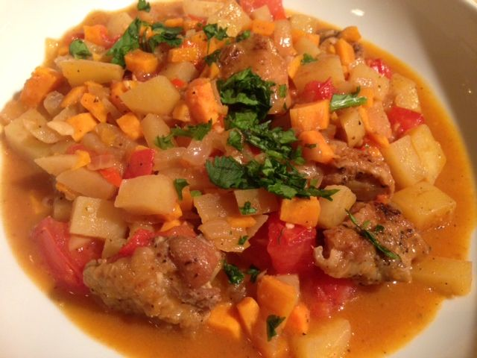 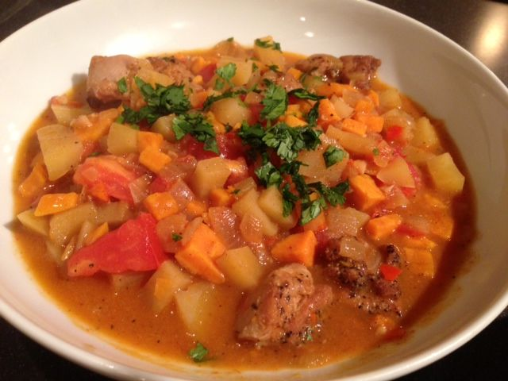 Korma has been around for centuries and, as with many of the classic curries, was perfected through a combination of Kashmir and Mogul adaptations. In its early days in India, Korma was the dish of the courts and a chef had to display excellence in its preparation in order to cook for royalty. Its rich and creamy, yellow sauce distinguishes it from all other Indian dishes.

Ingredients
1 tablespoon olive oil
½ pound meat: shrimp, lamb or chicken thighs, trimmed and cubed
1 medium onion, finely chopped
1 clove of garlic, crushed and miced
1 tablespoon curry (sambar) powder
1- 2 chillies, de-seeded if desired, minced
3 tablespoons white vinegar
1½ teaspoons brown sugar
1 cup chicken stock
1 medium potato, peeled and cut into very small (¼“) dice
1 very small sweet potato, peeled and cut into very small (¼“) dice
½ cup coconut milk or plain yogurt
1 medium-small vine ripened tomato, diced
¼ cup coriander, chopped
Salt & ground, black pepper – enough to season the meat and vegetables
Preparation:
Heat the oil in a large pan or deep saucepan and brown the meat on all sides. Remove from the pan and set aside. Add the onion and garlic and fry until soft and caramelized to your liking (old-school Indian cooks like them very caramelized).
Return the meat to the pan and stir through the curry/sambar powder and chilli, frying for 1 minute. Pour in the vinegar and allow to dissipate a few seconds.

Add the brown sugar, chicken stock, potatoes and sweet potatoes. Bring to the boil, reduce the heat and simmer for 20 - 30 minutes or until the meat is cooked and the potatoes are tender. Be sure to season everything with salt and pepper.
Stir in the coconut milk or yogurt and the tomato. Reheat gently and serve topped with coriander with steamed basmati rice.

