Korean Radish Pickle – recipe makes 4 to 6 servings

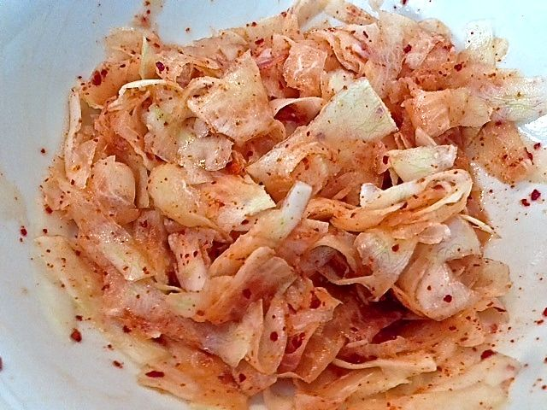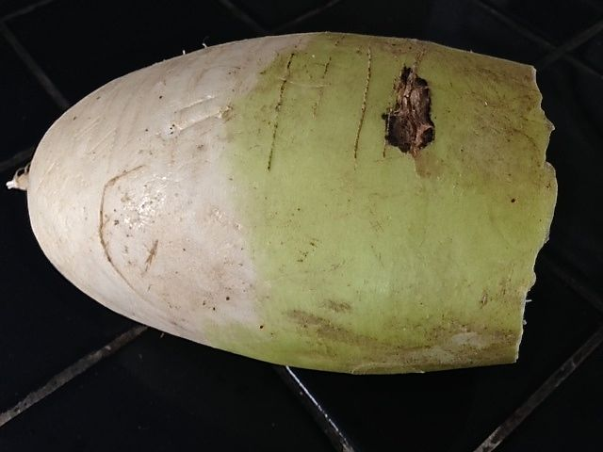

All Korean meals are accompanied by multiple, small side servings of fermented or pickled vegetables. This is a popular one.

Ingredients:
6 ounces daikon radish (it’s about a fifth of a normal-sized one - see notes below), sliced into short ribbons with vegetable peeler, or 1 bunch red radishes, thinly sliced
5 teaspoons granulated sugar
5 teaspoons Korean apple vinegar or rice vinegar
1½ teaspoons Korean chili flakes (gochugaru) or cayenne powder, to taste
½ teaspoon salt
1 small clove garlic, grated

Preparation:
In a medium bowl, mix together the radish ribbons, sugar, vinegar, chili flakes, salt and garlic; stir to coat the radishes well, ensuring that you coat every radish ribbon. I wear cleaned latex gloves and mix it all up well with my hands.

Cover and chill for at least 1 hour before serving.

Notes:
A typical Asian daikon radish weighs a little over 2 pounds. I know 6 ounces doesn’t sound like enough to provide 4 to 6 servings, but peeling it into ribbons produces a large volume. Also keep in mind that only a couple of ounces of this is served on the side with a Korean meal. If using plain, red radishes, don’t bother peeling them.

