Korean Pork Stir-Fry. This spicy recipe serves two.

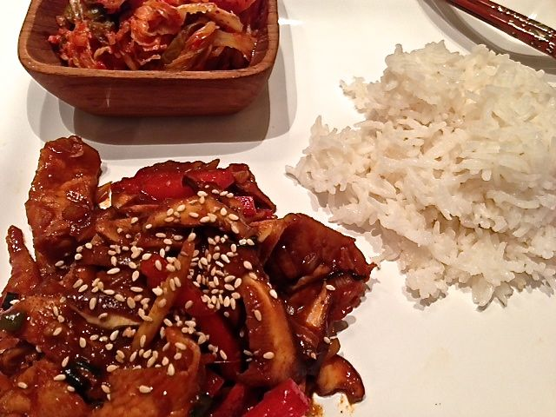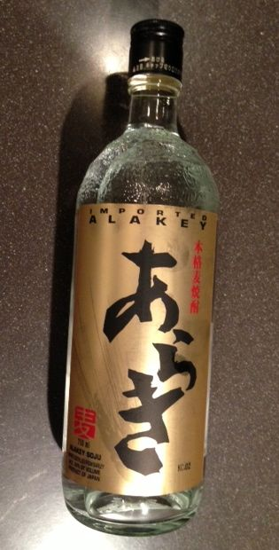

Ingredients:
½ pound pork (I like pork loin), thinly sliced - beef and chicken work great, too!
1 tablespoon sugar
1 tablespoon ground red pepper
2 tablespoons gochujang (Korean red-pepper paste – pronounced “go-joo-jong”)
2 tablespoons soju (rice liquor - tastes like sweet vodka), sake or plain vodka
2 tablespoons soy sauce
2 – 3 scallions, tops & bottoms, roughly sliced
2 cloves fresh garlic, minced
2” piece ginger, peeled, half minced and half cut into match sticks
1 small, white onion (about ½ cup’s worth), finely diced
4 ounces shitake mushrooms, sliced
1 small red bell pepper, sliced into 2” – 3”- long match sticks
4 ounces whole sugar snap peas/beans or snow peas
1 – 2 fresh chilies, sliced into 2” – 3”- long match sticks
Toasted sesame seeds for garnishing
Asian sesame oil for frying the meat

Preparation:
Mix the sugar, red pepper, gochujang, soju, soy sauce, scallions, garlic, minced ginger and diced onion into a marinade paste. Place the pork in a suitably sized container and coat it thoroughly with the marinade. Cover with cling-film and let sit for 30 minutes (does not have to be refrigerated while marinating).

Heat up an oiled wok until it starts smoking a bit. Add in the meat and all its marinade. Fry, stirring constantly, until caramelized. Add in the mushrooms, bell pepper, sugar snaps or snow peas, ginger match sticks chilies.

Lightly sprinkle toasted sesame seeds over each serving. Serve with boiled rice and a little spicy, fermented cabbage kimchi on the side.

