Korean Pork & Kimchi Stew (Kimchi Jjigae) for Two

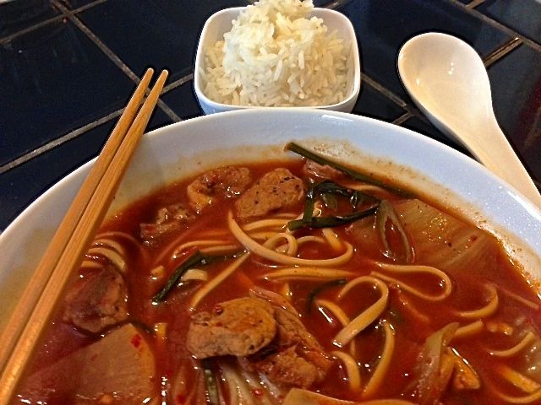

This Korean dish is a widely embraced way to use up leftovers with Kimchi. Every Korean family has their own way of making it. I like this recipe.

Ingredients:
8 ounces any pork, like pork belly or tenderloin, cut into small pieces
8 ounces Kimchi
4 cups water
1 tablespoon Korean fermented chili paste (gochujung)
½ teaspoon sugar
1 tablespoon soy sauce
Firm tofu, to taste, cut into chop-stick friendly cubes, or Korean noodles (optional)
1 – 2 scallions/green onions, sliced on the diagonal into ½“ pieces (optional)
Chives, to taste, chopped into 2” lengths (optional)
Fresh red chilis, chopped, or Korean red-pepper powder (gochugaru - optional)

Preparation:
In a medium saucepan, render any fat out of the pork over medium heat until pork is nicely caramelized. Add in Kimchi and mix well with the pork. Stir in the water, chili paste, sugar and soy sauce; cover and simmer, occasionally stirring until chili paste completely dissolves into the sauce.

Add in the tofu or Korean noodles, scallions, chives and chilis. Simmer until everything is heated through (or until noodles are done) and serve with steamed rice on the side.

