Korean Poached Chicken for Two

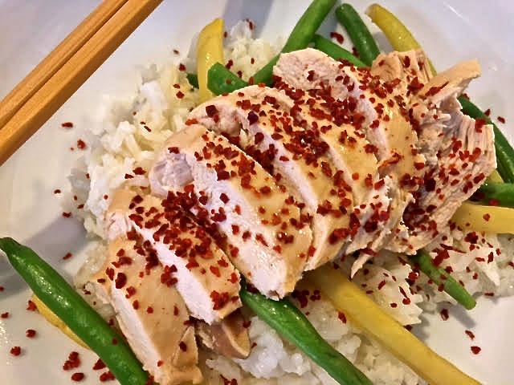

Reminiscent of Chinese “Bon Bon” chicken, this dish is delicate and mild in flavor.

Ingredients:
½ - ¾ pound boneless, skinless chicken breast, pounded to about ½“ thickness
1 small white onion or spring onion bulb, peeled and roughly chopped
2 scallions, both white and green parts, cut into ½” pieces
2” piece ginger, unpeeled, but roughly chopped for the pot
2 – 4 cloves garlic, peeled and smashed open
4 dried shitake mushrooms
½ teaspoon whole, black peppercorns
2 tablespoons Korean denjong (fermented soybean paste)
¼ cup soy sauce
Chicken broth – enough to cover everything in the pot by about ½“
2 ounces whole, fresh green and/or wax beans
2 servings cooked rice
Gojugaru (Korean red-pepper flakes), for garnish, to taste
Toasted sesame oil, for garnishing/finishing

Preparation:
Put the chopped vegetables, mushrooms, peppercorns, soybean paste, soy sauce and chicken in a wok or large saucepan. Cover with chicken broth by ½“ and bring to a boil. Bring the pot down to a low simmer and let the chicken poach in it about 8 minutes, until its internal temperature reaches 160° F.

When the chicken is to temperature, remove it to a cutting board. Skim the vegetables out of the poaching liquid and cook the beans in it until they’re just crisp-tender while you slice the chicken into chopstick-friendly pieces. Plate the beans over rice, then place the chicken on top of the beans. Spoon poaching liquid over the chicken, then drizzle with some sesame oil and a sprinkle of the red-pepper flakes.

Serve with kimchi and Korean pickled vegetables on the side.

