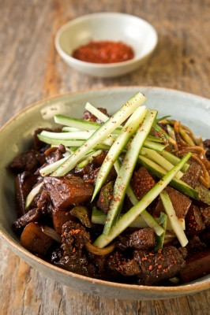 Korean Noodles with Black Bean Sauce (Jajangmyeon) - serves 2
Like pizza for New Yorkers, jajangmyeon is an imported dish (the black bean paste is a Chinese ingredient) that’s become part of the Korean identity—it’s eaten everywhere, especially late at night and especially as takeout.

Ingredients:
- 1 medium boiling potato, peeled and cut into ½ inch cubes
- 1 small zucchini, cut into ½ inch cubes
- ½ pound fresh jajangmyeon noodles or fresh Chinese egg noodles
- 1 tbsp vegetable oil
- ½ pound lean pork belly, cut into ½-inch cubes
- Coarse salt and freshly ground black pepper
- 1 small onion, coarsely diced
- ¼ cup black bean paste
- 1 small Korean cucumber (or ¼ hothouse cucumber, seeded), cut into matchsticks
- Gochugaru (ground red-pepper powder)

Directions:

Bring a pot of salted water to a boil and cook the potatoes until just easily pierced with a knife, being careful not to overcook them, about 10 minutes. Add the zucchini and cook for 1 minute. With a slotted spoon, transfer the vegetables to a sieve or colander and rinse with cold water to stop the cooking.

Add the noodles to the boiling water and cook according to the package directions. Drain and set aside. Meanwhile, heat the oil in a large nonstick skillet over high heat. Add the pork belly, season with salt and pepper, and cook, stirring now and then, until browned and crispy and all the fat is rendered, about 7 minutes. Remove the pork with a slotted spoon to a paper towel–lined plate and discard all but 2 tablespoons of the fat from the skillet.

Add the onion to the skillet and cook until beginning to soften and brown around the edges, about 2 minutes. Add the potatoes and zucchini, a pinch of salt, ¼ teaspoon black pepper, the black bean paste, 9 tablespoons water, and the reserved cooked pork and stir to combine. Bring to a boil, reduce the heat to a simmer, cover, and cook for 10 minutes.

Divide the cooked noodles evenly between 2 serving bowls and evenly ladle the black bean sauce over the noodles. Garnish each bowl with the cucumber and a pinch of ground red pepper.

