Korean Hot Wings - recipe serves two.

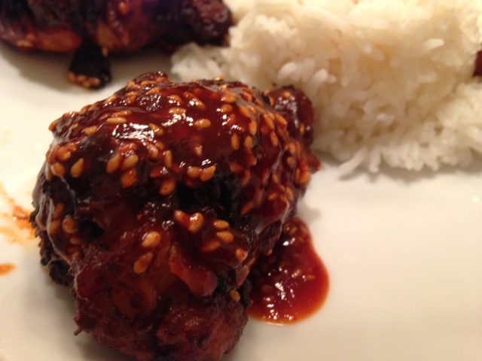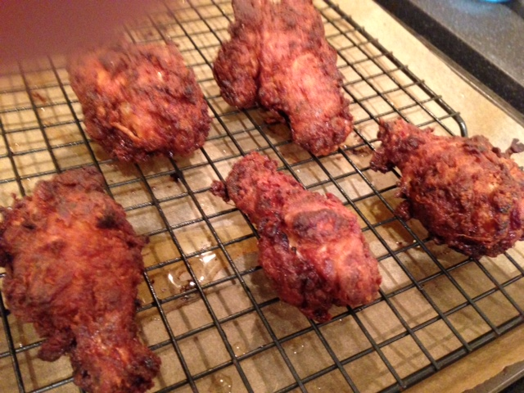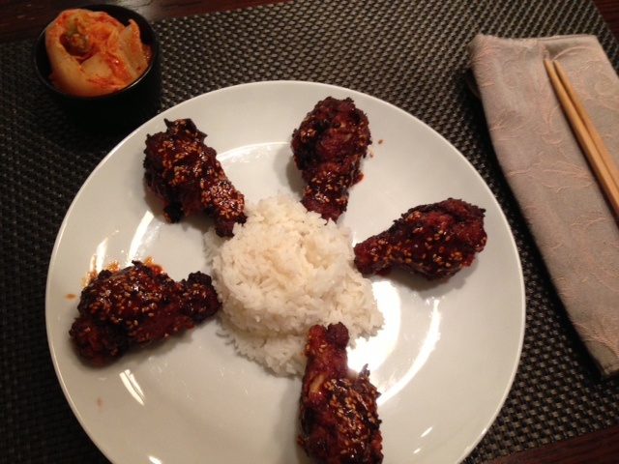

INGREDIENTS:
For the chicken wings –
1 to 1¼ lbs. chicken drumettes (10 drumettes) or wings (wings cut in ½ at the joint)
1 tablespoon sugar
2 tablespoons limejuice
2 tablespoons soy sauce
1 tablespoon sesame oil
2 tablespoons garlic, minced
2 tablespoons ginger, minced
2 tablespoons gochujang (Korean red-pepper paste)
2 cups all-purpose flour (for coating the wings before frying)
a few fresh chili peppers for garnish (optional)
oil (for deep frying)

For the glaze –
1 tablespoon ground, red pepper (make it two tablespoons for really-awesome hot!)
1 tablespoon gochujang (Korean red-pepper paste)
2 tablespoons rice vinegar
2 tablespoons honey
2 – 3 tablespoons toasted sesame seeds

PREPARATION: Preheat oven to 350° F.
Mix the sugar, limejuice, soy sauce, sesame oil, garlic, ginger and pepper paste into a marinade. Put the chicken pieces in a quart-sized Ziploc bag. Pour in the sauce and let it all marinade at least 25 minutes in the fridge.
Heat oil to 350° F. on a thermometer in a large, heavy-bottomed stockpot to a depth of 1-inch. Place the flour in a doubled paper bag. After allowing the marinated chicken to come to room temperature, place the chicken pieces in the bag, a few at a time (shake off excess marinade), and shake until well coated.
Working in batches, carefully place several pieces of chicken in the oil and fry for about 1 - 2 minutes on each side until the coating is a golden brown (it will continue to brown in the oven). Don't crowd the pieces. Remove the chicken from the oil and place each piece on a metal baking rack set on a sheet pan. Allow the oil to return to 350° F. before frying the next batch. When all the chicken is fried, bake for 15 minutes, until the chicken is no longer pink inside. If using, fry the whole chili peppers in the oil until crisp and drain on paper towels.
Mix the glaze ingredients together. Put two fried wings in a bowl at a time and carefully spoon glaze over them to thoroughly coat them – the crust is delicate, so go easy with them! Arrange the wings artfully on a decorative plate and garnish with the fried chilies. Serve with boiled jasmine rice and kim chi on the side. Garnish with the fried chilies, if using them.

