Korean Egg Custards with Shrimp for Two

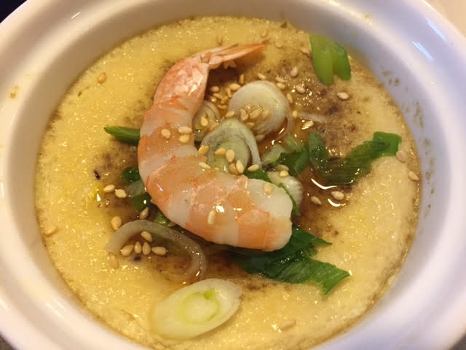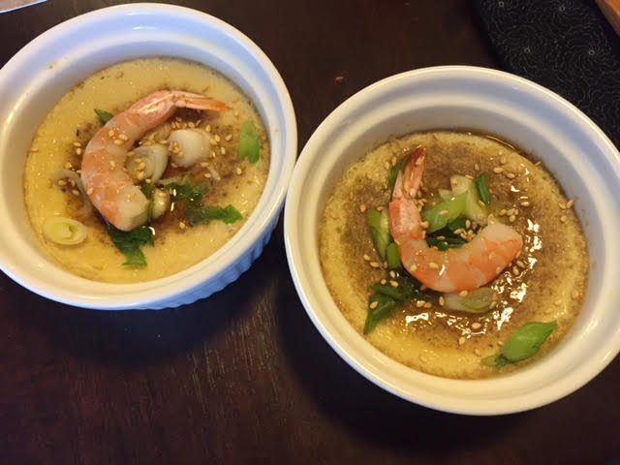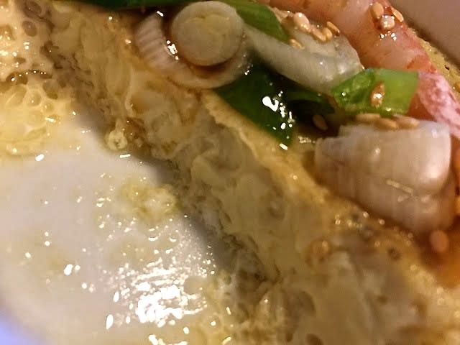

These silky, light, super savory and super easy egg custards are traditionally served as one of the several side dishes that normally accompany a typical Korean meal. They’re good on their own and even better topped with sweet shrimp and sliced scallions. Take care not to overcook them, as the texture can become tough and dry.

Ingredients:
4 large eggs
1 cup shrimp or vegetable bouillon
1 teaspoon fish sauce

½ teaspoon Korean salted shrimp (Saeujeot 새우젓), finely chopped
½ teaspoon salt
2 – 4 small shrimp, peeled and deveined
1 scallion, thinly sliced on an angle
Toasted sesame oil, for drizzling
Roasted sesame seeds, for sprinkling

Special equipment: Two 10-ounce heatproof bowls or ramekins

Preparation:
In a large, 16-ounce measuring cup, whisk together the eggs, bouillon, fish sauce, Korean salted shrimp and salt. Pour the mixture into the bowls or ramekins just ¾ of the way up (they do puff up a little). Arrange the bowls in a large, wide pot with a lid.
Add enough boiling water into the pot to reach two-thirds of the way up the sides of the bowls or ramekins. Bring the water to a gentle simmer, cover the pot, and steam until the custards are slightly wobbly in the center, 6 to 7 minutes.
Garnish the custards with the shrimp and scallions, cover the pot and steam until the shrimp are cooked through and the custards are set, about 3 minutes more.
Top the custards with a drizzle of sesame oil and a sprinkle of sesame seeds. Serve warm or at room temperature.

