Korean Cucumber Kimchi – recipe makes 4 servings

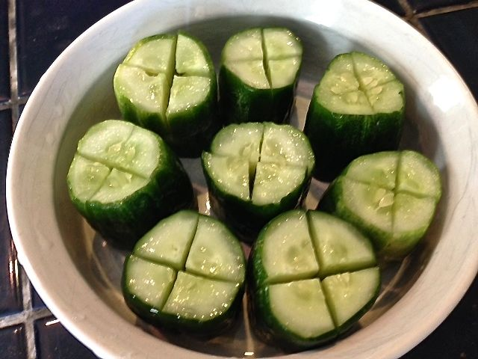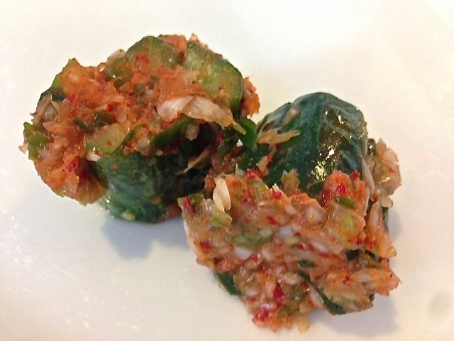

All Korean meals are accompanied by multiple, small side servings of fermented or pickled vegetables. Kimchi is always one of them. This is a favorite variation of it easily made at home.

Ingredients:
4 medium-small Korean, Persian or Kirby cucumbers
4 tablespoons salt
1 tablespoon Korean chili flakes (gochugaru), or to taste
1 tablespoon salted shrimp (saewoo jut)
1 tablespoon sugar
4 scallions or spring onions, chopped into 2” to 3” pieces
1 small clove garlic
1” piece ginger
1 medium onion, roughly chopped
15 chives, cut into 2” pieces

Preparation:
Slice off the round ends from each cucumber so that you will be able to slice each into two 2” pieces. Stand the pieces on their cut sides. Cut each piece two-thirds of the way down into quarters lengthwise, keeping them attached at the bottom. Sprinkle the cucumbers well with plenty of salt, making sure to stuff inside the cuts of the cucumbers. Place in a single layer on their cut sides in a glass or other nonreactive dish, cover and let sit at room temperature for 1 hour to soften.

Meanwhile, prepare the chili paste mix. In the bowl of a food processor, combine the chili flakes, salted shrimp, sugar, scallions, garlic, ginger, onions, chives and 2 tablespoons water. Pulse until a coarse paste forms.

Rinse the salted cucumbers very well under cold water, making sure to clean out the crevices, and shake dry. Spread open the cucumbers and, using latex gloves, stuff the chili mix into and around each piece generously. Place in a container, packed somewhat tightly, and press in any remaining chili paste and liquid. Seal tightly.

Allow the cucumbers to ferment in the fridge for 72 hours (3 days). Keep refrigerated until ready to serve.

