Bulgogi Ddukbokki (Non-Spicy, Salty-Sweet Sautéed Korean Beef with Rice Cakes) for Two

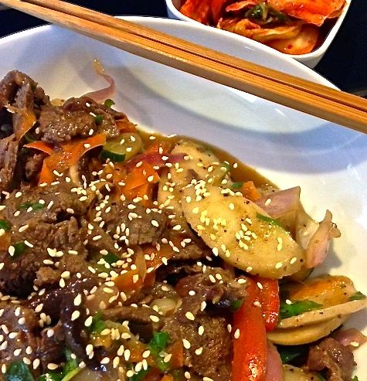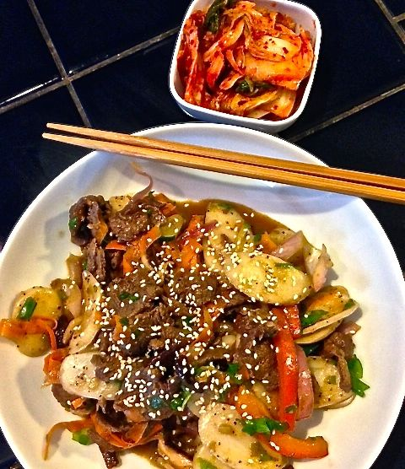
Ingredients:
¼ pound beef (sirloin, tenderloin or rib eye, partially frozen)
2 ounces white and/or red onion, thinly sliced
5 – 6 ounces dduk or tteok (sliced Korean rice cakes, pronounced “dook”)
10 teaspoons soy sauce
4 teaspoons honey or sugar
3 teaspoons toasted sesame oil
2 fat cloves garlic, minced
2 teaspoons minced ginger root
2 green onions, chopped (separate white & green parts)
½ teaspoon black pepper
¼ + cup water
2 – 3 ounces shiitake mushrooms, stems removed/caps only, sliced thinly
1 small carrot, shaved into ribbons with a vegetable peeler
2 – 3 ounces other vegetables, like bell peppers, zucchini, etc., sliced thinly
1 teaspoon toasted sesame seeds
Vegetable oil
Preparation:
In a small bowl, stir together soy sauce, honey or sugar, toasted sesame oil, minced garlic, ginger, white parts of green onion, and black pepper. Set the marinade aside.

Slice the beef very thin – close to paper-thin, if you can. This will be much easier if the beef is partially frozen. The meat should appear frozen, but give slightly when pushed with a finger. Add about ½ of the marinade and sliced onions to the sliced beef. Marinate for at least an hour, preferably overnight. I do it in a Ziploc bag.

Soak the rice cakes in cold water for at least 20 minutes, until soft and flexible. I soak them straight from the freezer and it takes at least an hour. Drain them well.
Bring the meat to room temperature, if you had it marinating in the fridge, and prepare the vegetables.

Once you vegetables are all prepped, heat a pan over medium heat. Once heated, add just enough vegetable oil to coat the pan. Sauté the beef until just cooked. This should happen very quickly because of the thinness of the beef. Add mushrooms and sauté for about a minute. Add the carrots and other vegetables and sauté for about another minute or two.

Add about ¼ cup of water to the leftover marinade. Add this diluted marinade and rice cakes to the pan. Stir until the rice cakes soften, sauce thickens, and a shiny glaze covers the rice cakes. Don’t overcook; the rice cakes will become mushy and release too much starch into the sauce. If the sauce becomes too thick, add more water to thin it out. Stir in the chopped green onions (the green parts) just before the heat is turned off.

Garnish with a sprinkle of toasted sesame seeds and serve immediately while hot. Of course, serve with kimchi on the side.

