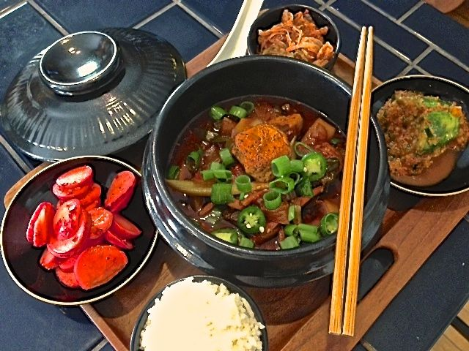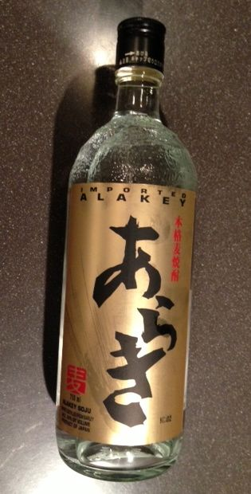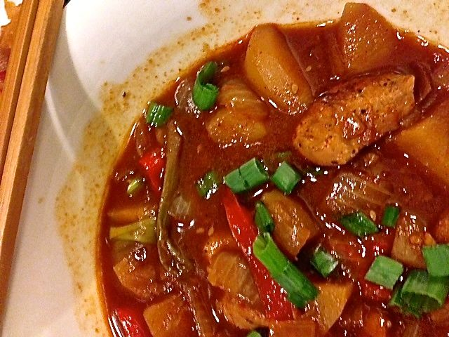

Jjimdac - Korean Braised Chicken & Vegetables (recipe serves 2). SPICY HOT!!!

Ingredients:
½ pound chicken, cut into 1” pieces
Salt, ground black pepper & granulated garlic powder
1 tablespoon Asian sesame oil
7 – 8 tablespoons of Korean umma paste (see note below to make this amount)
1½ teaspoons Korean or Japanese rice soju liquor, sake or vodka
1½ teaspoons honey
1½ teaspoons toasted sesame seeds
4 small new potatoes, peeled and cut into chop-stick-friendly pieces
1 medium-sized yellow onion, coarsely chopped
1 medium carrot, julienne-cut into 3” lengths (can replace with red-bell pepper)
1 bunch scallions cut into 2-inch lengths on the bias
1 fresh jalapeño chili, thinly sliced (optional for garnish)
½ ounce sliced scallion greens (optional for garnish)

Directions:
Whisk together 1¼ cups water, the umma paste, soju, honey, and sesame seeds. Set the sauce aside.

Season the chicken all over with salt, garlic powder and just a little black pepper. Heat the oil in a wok or large saucepan over high heat until just smoking. Add the chicken and brown well on all sides.

When the chicken is well browned, add the potatoes, onions, carrots, scallions, and reserved sauce to the pot, season with a bit more salt and stir everything together, coating well with the sauce. Reduce the heat to “low,” cover, and cook, stirring occasionally, until the chicken is cooked and potatoes are tender (about an ½ hour).

Granish with the sliced chilies and/or sliced scallion greens. Serve by itself or with rice and, of course, with Kimchi on the side.

Note: To make the umma paste for this recipe, combine 2 large garlic cloves, peeled and crushed/minced to a paste, 4½ teaspoons gochugaru (Korean-style red-pepper powder), 3 tablespoons soy sauce, 4½ teaspoons gochujang (Korean red pepper paste) and 4½ teaspoons soju. Mix until smooth.

