Korean Beef Lettuce Wraps (recipe serves 2).

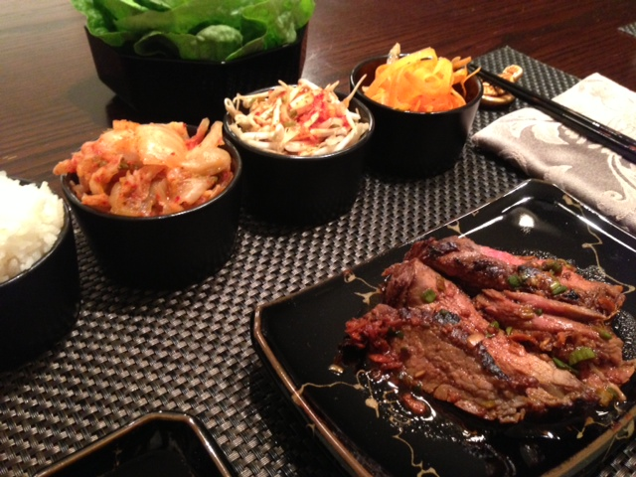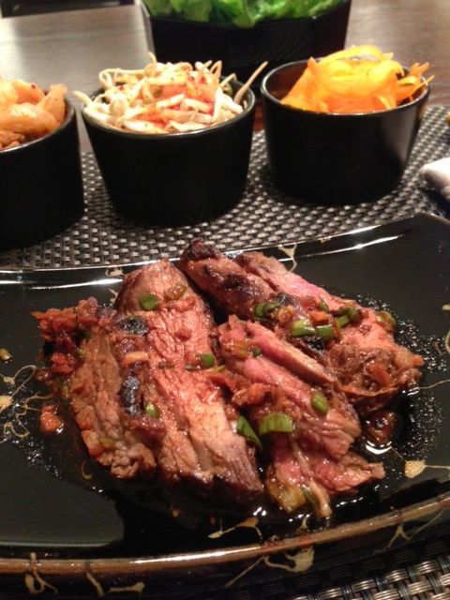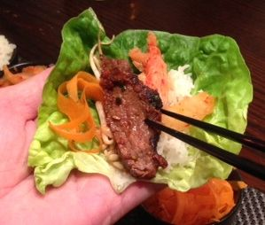

Ingredients:
½ pound skirt or flank steak, cut in two, equal pieces
¼ cup soy sauce
3 tablespoons rice vinegar
1 scallion, white and 2 inches of the green parts, finely chopped, plus additional chopped scallions for garnish
2 teaspoons firmly packed brown sugar
¾”- long piece fresh ginger, peeled and finely chopped or grated
1½ teaspoons Asian-style sesame oil, plus just a bit extra for sautéing the beef
1 teaspoon ground red pepper
Salt and ground, black pepper
Boston lettuce leaves (for making wraps with the beef)
2 servings boiled jasmine rice, kim chi and/or other side components of your choice

Preparation:
Combine the soy sauce, vinegar, scallion, sugar, ginger, 1½ teaspoons sesame oil, and red pepper in a bowl. Whisk well to blend. Reserve ¼ cup and set aside. Pour the rest into a plastic Ziploc bag. Add the skirt steak and seal. Marinate in the refrigerator, turning the bag occasionally, for at least 2 hours or overnight.

Remove steak from marinade; pat dry with paper towels. Heat a scant amount of sesame oil in a medium skillet or wok over high heat until almost smoking. Season the meat with salt and black pepper. Place in the skillet, reduce heat to medium-high. Cook until seared on the outside and rare to medium-rare on the inside, 2 to 3 minutes per side. Transfer to a platter, cover loosely with foil, and let rest 5 minutes. Cut into very thin slices, holding the knife at an angle and cutting against the grain. Toss with the reserved ¼ cup sauce in a bowl until well coated.

Mound the beef on individual serving plates. Serve with lettuce leaves on the side. Serve the rice in small bowls on the side, along with spicy, fermented cabbage kim chi, Korean bean sprouts and shredded carrot in other bowls.

With chopsticks, place beef slices in lettuce leaves, along with a little rice, kim chi and other vegetable components. Form into a small wrap-packet and shove the whole thing in your mouth, just like they do in Korea!

