Korean BBQ Kalbi for Two

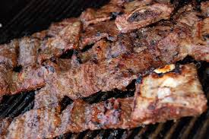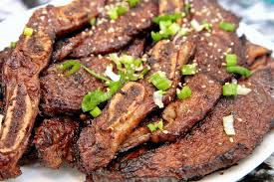

Ingredients:
1 pound Korean short ribs (the bones weigh a lot), LA- or flanken-cut (see note below), or a rib eye steak, trimmed and cut thinly into ¼“ slices
4 tablespoons soy sauce
10½ teaspoons brown sugar
7½ teaspoons toasted sesame oil
2 teaspoons grated ginger
7 to 8 grinds black pepper
¼ teaspoon salt
3 cloves garlic, grated
2 semi-hard sweet pears, such as Barlett, or 1 Asian pear, peeled and grated on a box grater
Cooked jasmine rice, for serving
Green leaf lettuce leaves, for serving
Sesame leaves (perilla), for serving, optional

Preparation:
Place the beef in a large Ziploc bag. Mix together thoroughly the soy sauce, brown sugar, sesame oil, ginger, black pepper, salt, garlic and grated pear; pour into the Ziploc and massage into the meat well. Chill and let marinate for at least 2 hours or up to overnight.

Heat a grill or grill pan until very hot. Shake off any excess marinade from the meat and grill the beef strips until desired doneness, about 30 seconds each side for rare.
Serve immediately with white rice, green leaf lettuce, Ssamjang Sauce (see my recipe for it) and sesame leaves, if you can find them. Place a small scoop of rice, a smear of Ssamjang Sauce and a piece of beef into a lettuce leaf. Wrap and enjoy.

Note:
LA- or flanken-cut short ribs are ribs that are cut into slices across the bone. Whole Foods sells them cut this way. If you are serving the meat with bones still attached, trim the strip of bones off, then snip the meat into bite-size pieces with kitchen shears. Gnaw on the bones like a true Korean.

