American-Style Kim-Chi Coleslaw

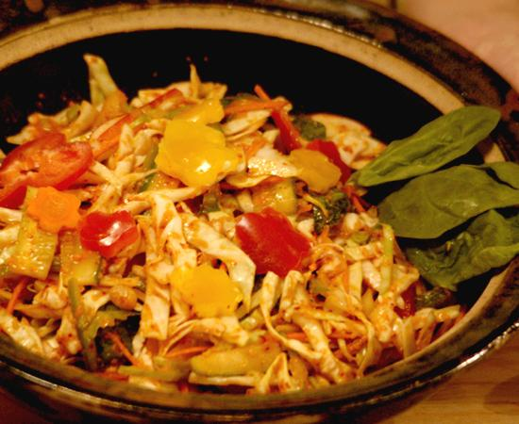
Sauce Ingredients:
4 lemons, juiced
1 small tin anchovies
1 clove garlic
1 thumb-sized piece ginger root
2 tablespoons soy sauce
4 tablespoons crushed red pepper flakes
4 tablespoons olive oil
1 tsp onion powder
1 tablespoon brown sugar
salt
1 whole Daikon (big, white Asian radish), cubed.
For sauce:
Juice the lemons. Finely puree garlic, ginger and anchovies.

Add cubed Daikon, soy sauce, spicy red pepper flakes, olive oil, ground onion, brown sugar and salt to a food processor. Then add anchovy mixture and lemon juice. Puree until smooth.
Kim Chi:
1 head Napa cabbage (thin-sliced, soaked in salt water)
1 bunch American radish, for garnish
1 bunch scallions, thinly sliced
4 pickle cucumbers, sliced lengthwise in 2” sections
3 cups baby spinach
3 carrots, sliced in strips lengthwise on the mandolin for garnish
1 each green, red, yellow bell peppers, thin-sliced same length as other vegetables
For Kim Chi:
In a large salad bowl, combine cabbage, spinach and thinly sliced vegetables (of similar sizes). Add the sauce and toss well.

