Kheema: Indian Ground Lamb with Peas
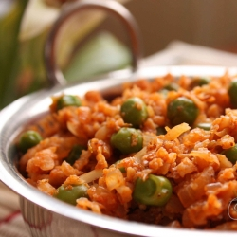 Recipe serves 4.

Ingredients:

- 3 tablespoons cooking oil
- 1 medium onion, finely diced
- 4 teaspoons garlic paste
- 2 teaspoons ginger paste
- 2 teaspoons ground coriander
- 1 teaspoon paprika
- 1/2 teaspoon garam masala
- 1/2 teaspoon ground cumin
- 1/2 teaspoon cayenne
- 1 pound ground lamb
- 2 medium tomatoes, chopped
- Kosher salt and freshly ground black pepper
- 1 cup shucked fresh English peas or 1/2 cup frozen peas, thawed
- 2 teaspoons malt vinegar or apple cider vinegar
- 1/4 cup chopped fresh cilantro, plus a few extra leaves for garnish
- 4 chapatis, warmed

Directions:

In a large skillet, warm the oil over medium-high heat. Add the onions and cook until golden. Add the garlic and ginger, and sauté for another minute. Stir in the coriander, paprika, garam masala, cumin and cayenne, if using and cook for 1 minute.

Add the lamb, breaking up lumps with a spoon, and sauté until the meat is no longer pink. Add the tomatoes, 1 cup of water and season with salt and pepper. Sprinkle in the fresh English peas. Stir well and simmer, partially covered, about 10 minutes or if using frozen peas, add them now, and cook another 5 minutes, partially covered.

Stir in the vinegar and chopped cilantro. Garnish with torn cilantro leaves and serve with warm chapatis (scoop up with pieces of torn chapati). Also is nice to serve with white basmati rice!

